**THIRD SUNDAY OF EASTER**

# May 4, 2025 ATD

“Worthy is the Lamb who was slain, to receive power and wealth and wisdom and might and honor and glory and blessing!’”

**PEACE LUTHERAN CHURCH**

1451 Ebenezer Rd T Cincinnati, OH 45233 T 513-941-5177

[**www.peacechurchlink.com**](http://www.peacechurchlink.com)

**About This Service**

The Sundays of the season of Easter are named after the first word(s) of the assigned Introit (Entrance Psalm). The Introit for this Sunday (One-Year Lectionary) is taken from Psalm 33 and includes one of the most beautiful and theologically-rich Latin phrases to be handed down to us: Misericordias Domini (Miss-er-a-CORD-ee-as Dom-in-ee) “the steadfast love of the Lord” (ESV). “The earth is full of the steadfast love of the Lord” because our merciful-hearted Good Shepherd first lays down His life for the sheep and then rises to shepherd us unto into eternal life.

The time before the Divine Service begins is a time for meditation and prayer. It’s a time for us to prepare our hearts and minds to hear God’s Word and receive His gifts. Therefore, we ask that you would please remain silent as you enter the sanctuary out of reverence for God and respect for one another.

**Are My Children Welcome?**

In God’s eyes we’re all children. Yes, your little ones are more than welcome! If your child needs a little extra room to “make a joyful noise” you’re welcome to take them out of the sanctuary and into the narthex or the Fellowship Hall.

**How Do I Become a Lutheran Christian?**

If you’re exploring the Lutheran Church, Pastor Shaw would be happy to offer guidance or answer your questions. Our website peacechurchlink.com is also a good resource. When you’re ready, there’s a formal process of reading, study, and prayer that culminates in being received into the Lutheran Church.

**Can I Take Communion?**

The Lord’s Supper is celebrated at this congregation in the confession and glad confidence that, as our Lord says, He gives into our mouths not only bread and wine but His very body and blood to eat and to drink for the forgiveness of sins and to strengthen our union with Him and with one another. Our Lord invites to His table those who trust His Words, repent of all sins, and set aside any refusal to forgive and love as He forgives and loves us, that they may show forth His death until He comes. Holy Communion is a confession of the faith which is confessed at this altar, any who are not yet instructed, in doubt, or who hold a confession differing from that of this congregation and the Lutheran Church – Missouri Synod, are asked to first speak with the pastor before communing.

485 LONG BEFORE THE WORLD IS WAKING

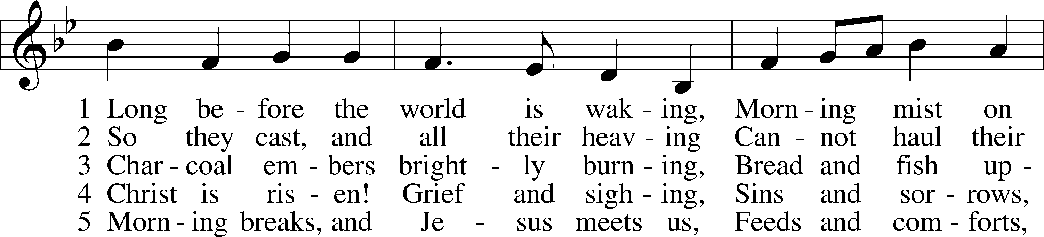

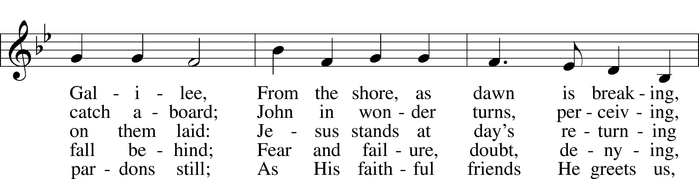

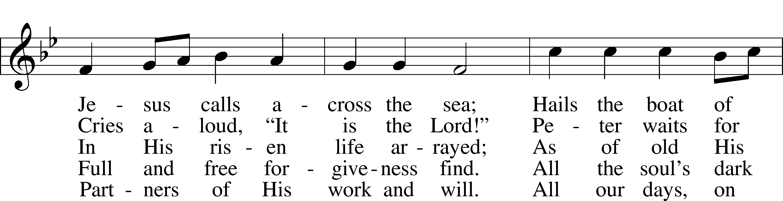

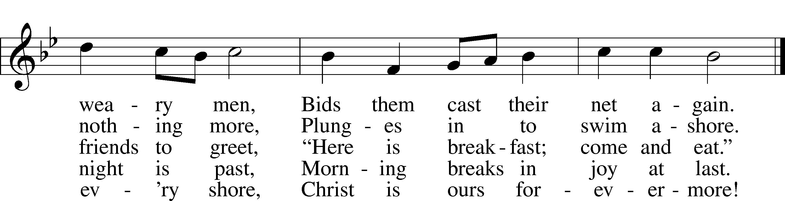

Text: Timothy Dudley-Smith, 1926–2024 Tune: Geistreiches Gesang-Buch, 1698, Darmstadt Text: © 1984 Hope Publishing Co. Used by permission: LSB Hymn License no. 110004388 Tune: Public domain

# CONFESSION AND ABSOLUTION

Stand

The sign of the cross may be made by all in remembrance of their Baptism.

INVOCATION

P In the name of the Father and of the T Son and of the Holy Spirit.

C **Amen.**

EXHORTATION LSB 151

P If we say we have no sin, we deceive ourselves, and the truth is not in us.

C **But if we confess our sins, God, who is faithful and just, will forgive our sins and cleanse us from all unrighteousness.**

Silence for reflection on God’s Word and for self-examination.

CONFESSION OF SINS LSB 151

P Let us then confess our sins to God our Father.

C **Most merciful God, we confess that we are by nature sinful and unclean. We have sinned against You in thought, word, and deed, by what we have done and by what we have left undone. We have not loved You with our whole heart; we have not loved our neighbors as ourselves. We justly deserve Your present and eternal punishment. For the sake of Your Son, Jesus Christ, have mercy on us. Forgive us, renew us, and lead us, so that we may delight in Your will and walk in Your ways to the glory of Your holy name. Amen.**

ABSOLUTION LSB 151

P Almighty God in His mercy has given His Son to die for you and for His sake forgives you all your sins. As a called and ordained servant of Christ, and by His authority, I therefore forgive you all your sins in the name of the Father and of the T Son and of the Holy Spirit.

C **Amen.**

# SERVICE OF THE WORD

INTROIT Psalm 145:4–7, 9; antiphon: v. 10

All your works shall give thanks to you, O Lord,  
 **and all your saints shall bless you!**One generation shall commend your works to another,  
 **and shall declare your mighty acts.**On the glorious splendor of your majesty,  
 **and on your wondrous works, I will meditate.**  
They shall speak of the might of your awesome deeds,  
 **and I will declare your greatness.**They shall pour forth the fame of your abundant goodness  
 **and shall sing aloud of your righteousness.**The Lord is good to all,  
 **and his mercy is over all that he has made.**  
**Glory be to the Father and to the Son**  
 **and to the Holy Spirit;**  
**as it was in the beginning,**  
 **is now, and will be forever. Amen.**  
All your works shall give thanks to you, O Lord,  
 **and all your saints shall bless you!**

KYRIE LSB 152



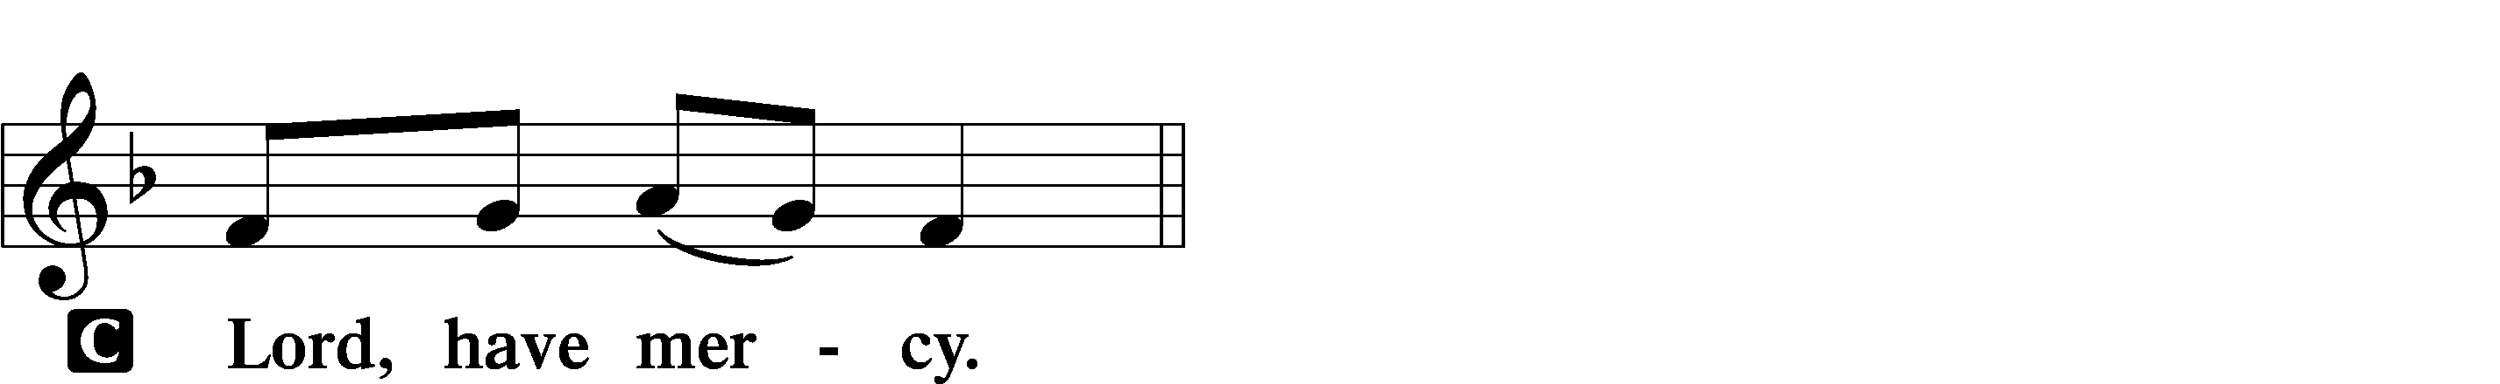

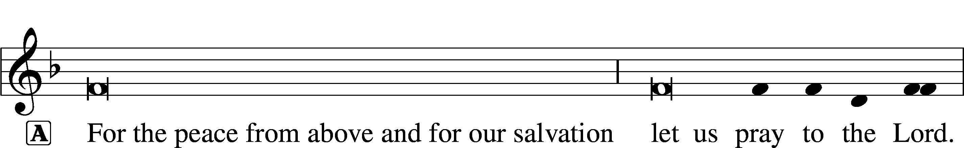

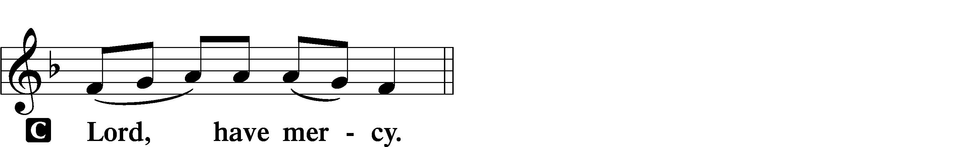

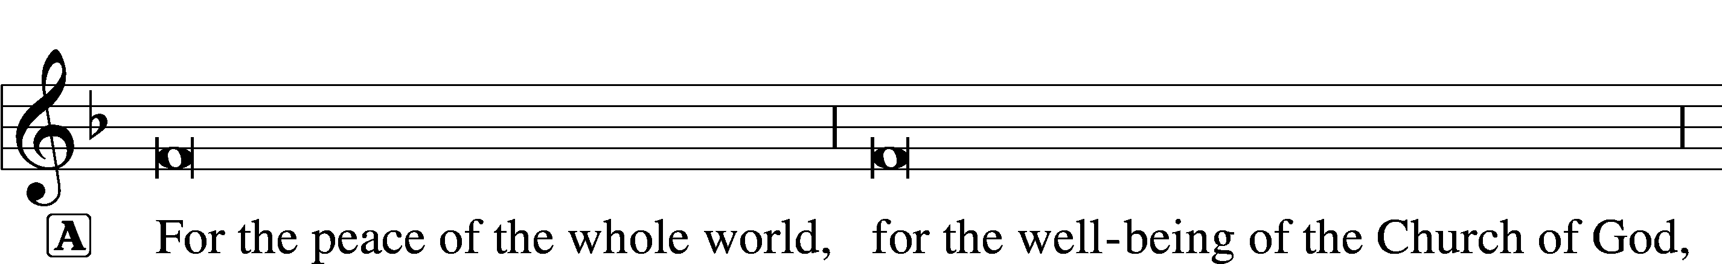



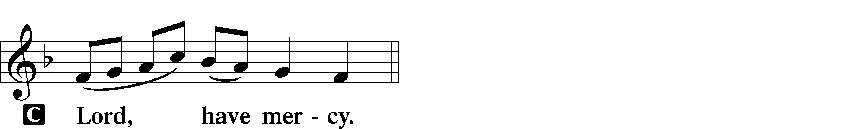

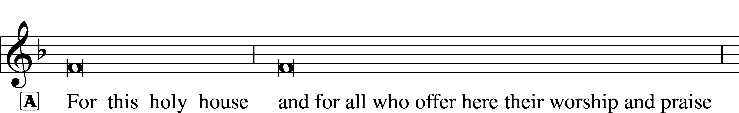



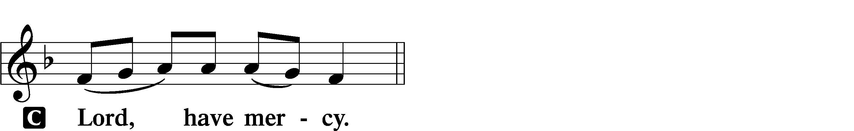





THIS IS THE FEAST LSB 155

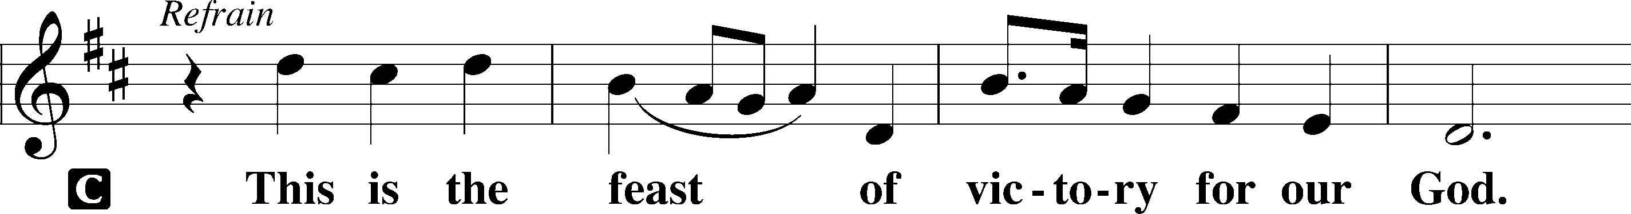

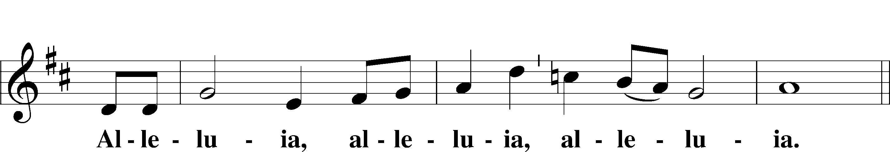

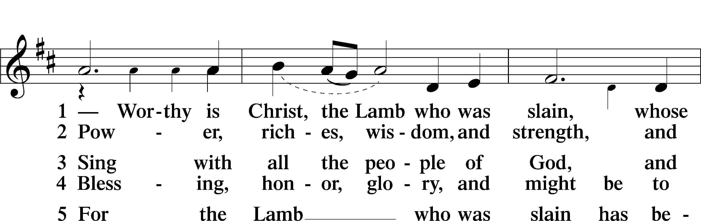

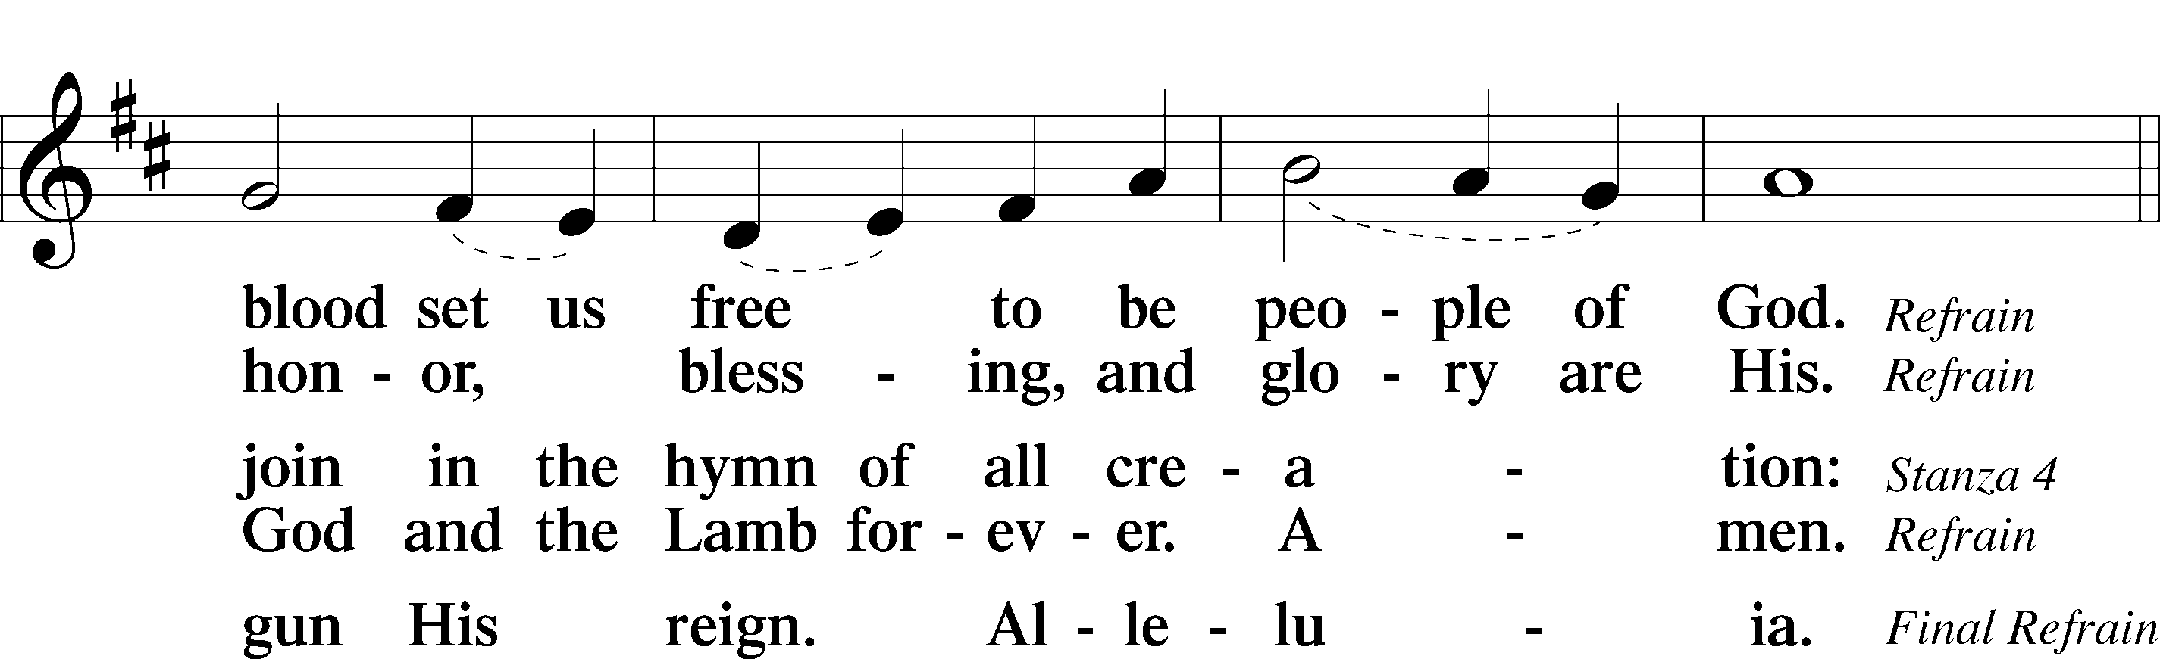

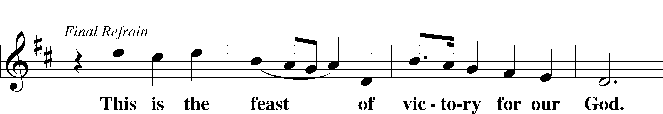

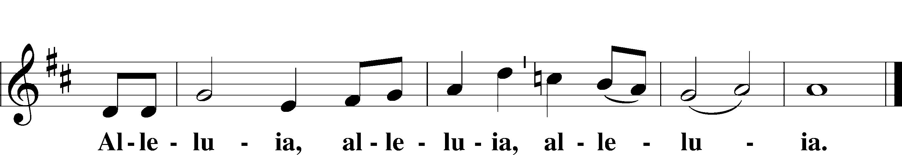

SALUTATION AND COLLECT OF THE DAY

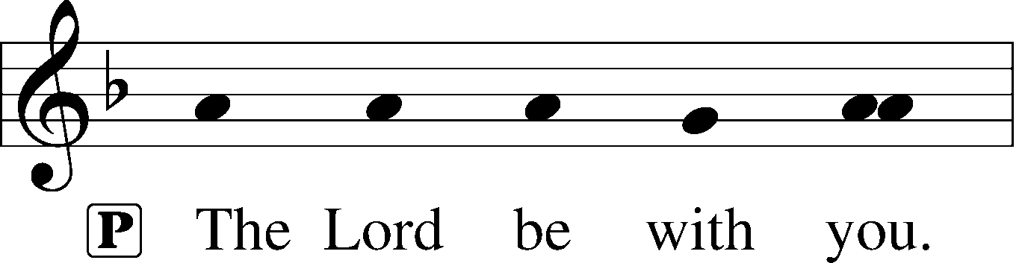

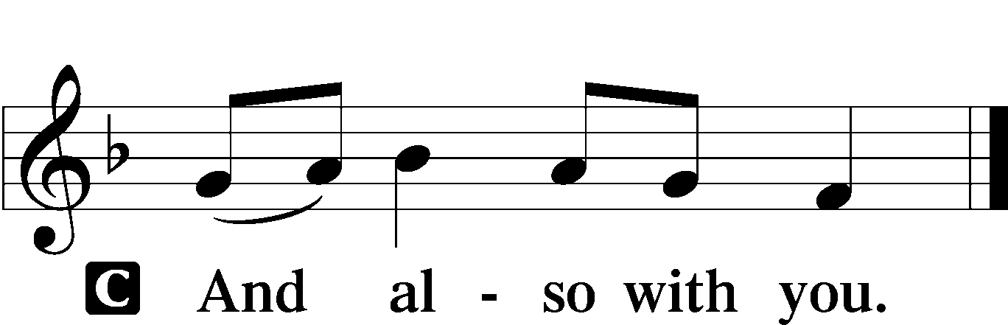

P Let us pray.

O God, through the humiliation of Your Son You raised up the fallen world. Grant to Your faithful people, rescued from the peril of everlasting death, perpetual gladness and eternal joys; through Jesus Christ, our Lord, who lives and reigns with You and the Holy Spirit, one God, now and forever.

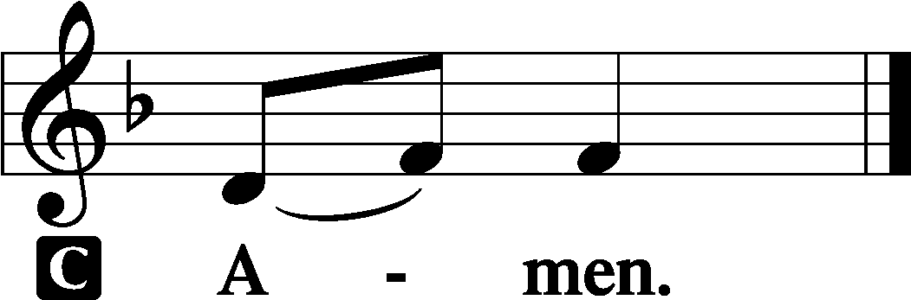

Sit

FIRST READING Acts 9:1–22

1But Saul, still breathing threats and murder against the disciples of the Lord, went to the high priest 2and asked him for letters to the synagogues at Damascus, so that if he found any belonging to the Way, men or women, he might bring them bound to Jerusalem. 3Now as he went on his way, he approached Damascus, and suddenly a light from heaven flashed around him. 4And falling to the ground he heard a voice saying to him, “Saul, Saul, why are you persecuting me?” 5And he said, “Who are you, Lord?” And he said, “I am Jesus, whom you are persecuting. 6But rise and enter the city, and you will be told what you are to do.” 7The men who were traveling with him stood speechless, hearing the voice but seeing no one. 8Saul rose from the ground, and although his eyes were opened, he saw nothing. So they led him by the hand and brought him into Damascus. 9And for three days he was without sight, and neither ate nor drank.

10Now there was a disciple at Damascus named Ananias. The Lord said to him in a vision, “Ananias.” And he said, “Here I am, Lord.” 11And the Lord said to him, “Rise and go to the street called Straight, and at the house of Judas look for a man of Tarsus named Saul, for behold, he is praying, 12and he has seen in a vision a man named Ananias come in and lay his hands on him so that he might regain his sight.” 13But Ananias answered, “Lord, I have heard from many about this man, how much evil he has done to your saints at Jerusalem. 14And here he has authority from the chief priests to bind all who call on your name.” 15But the Lord said to him, “Go, for he is a chosen instrument of mine to carry my name before the Gentiles and kings and the children of Israel. 16For I will show him how much he must suffer for the sake of my name.” 17So Ananias departed and entered the house. And laying his hands on him he said, “Brother Saul, the Lord Jesus who appeared to you on the road by which you came has sent me so that you may regain your sight and be filled with the Holy Spirit.” 18And immediately something like scales fell from his eyes, and he regained his sight. Then he rose and was baptized; 19and taking food, he was strengthened.

For some days he was with the disciples at Damascus. 20And immediately he proclaimed Jesus in the synagogues, saying, “He is the Son of God.” 21And all who heard him were amazed and said, “Is not this the man who made havoc in Jerusalem of those who called upon this name? And has he not come here for this purpose, to bring them bound before the chief priests?” 22But Saul increased all the more in strength, and confounded the Jews who lived in Damascus by proving that Jesus was the Christ.

A This is the Word of the Lord.

C **Thanks be to God.**

EPISTLE Revelation 5:1–14

1Then I saw in the right hand of him who was seated on the throne a scroll written within and on the back, sealed with seven seals. 2And I saw a strong angel proclaiming with a loud voice, “Who is worthy to open the scroll and break its seals?” 3And no one in heaven or on earth or under the earth was able to open the scroll or to look into it, 4and I began to weep loudly because no one was found worthy to open the scroll or to look into it. 5And one of the elders said to me, “Weep no more; behold, the Lion of the tribe of Judah, the Root of David, has conquered, so that he can open the scroll and its seven seals.”

6And between the throne and the four living creatures and among the elders I saw a Lamb standing, as though it had been slain, with seven horns and with seven eyes, which are the seven spirits of God sent out into all the earth. 7And he went and took the scroll from the right hand of him who was seated on the throne. 8And when he had taken the scroll, the four living creatures and the twenty-four elders fell down before the Lamb, each holding a harp, and golden bowls full of incense, which are the prayers of the saints. 9And they sang a new song, saying,

“Worthy are you to take the scroll  
 and to open its seals,  
for you were slain, and by your blood you ransomed people for God  
 from every tribe and language and people and nation,  
10and you have made them a kingdom and priests to our God,  
 and they shall reign on the earth.”

11Then I looked, and I heard around the throne and the living creatures and the elders the voice of many angels, numbering myriads of myriads and thousands of thousands, 12saying with a loud voice, “Worthy is the Lamb who was slain, to receive power and wealth and wisdom and might and honor and glory and blessing!” 13And I heard every creature in heaven and on earth and under the earth and in the sea, and all that is in them, saying, “To him who sits on the throne and to the Lamb be blessing and honor and glory and might forever and ever!” 14And the four living creatures said, “Amen!” and the elders fell down and worshiped.

A This is the Word of the Lord.

C **Thanks be to God.**

Stand

ALLELUIA AND VERSE LSB 156

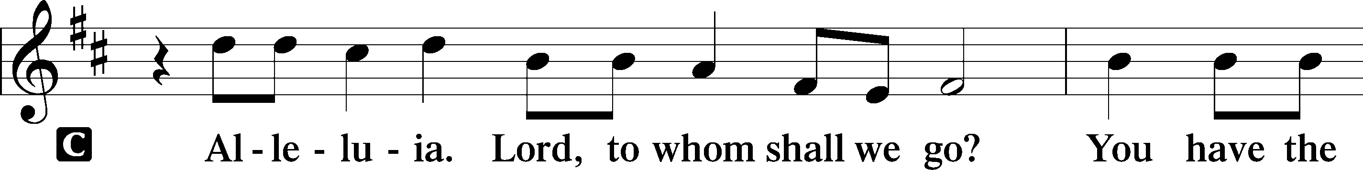

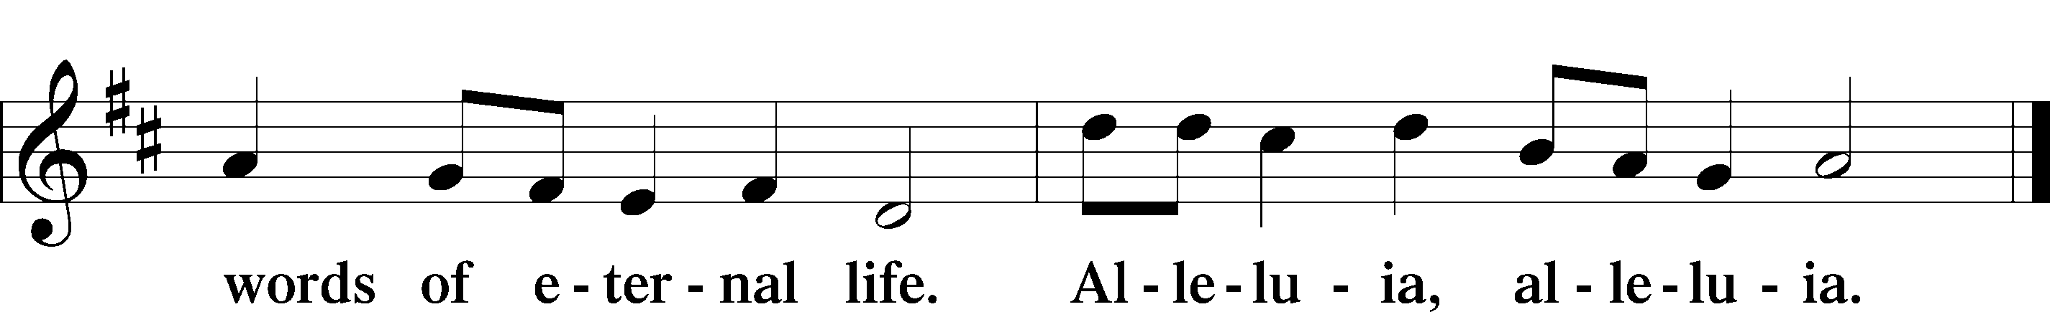

HOLY GOSPEL John 21:1–19

P The Holy Gospel according to St. John, the twenty-first chapter.

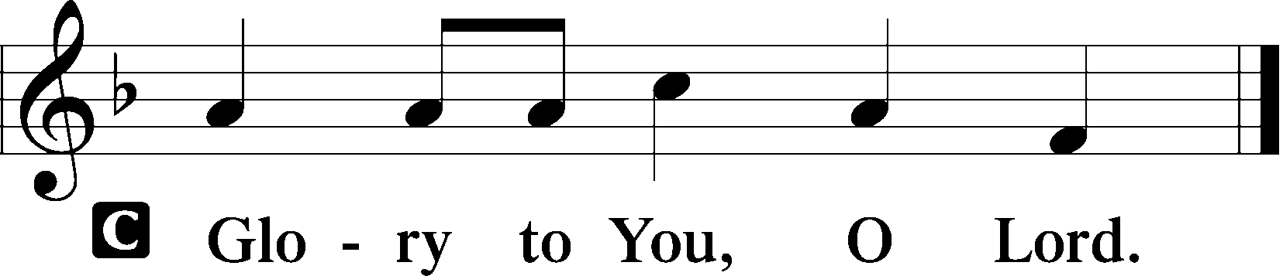

1After this Jesus revealed himself again to the disciples by the Sea of Tiberias, and he revealed himself in this way. 2Simon Peter, Thomas (called the Twin), Nathanael of Cana in Galilee, the sons of Zebedee, and two others of his disciples were together. 3Simon Peter said to them, “I am going fishing.” They said to him, “We will go with you.” They went out and got into the boat, but that night they caught nothing.

4Just as day was breaking, Jesus stood on the shore; yet the disciples did not know that it was Jesus. 5Jesus said to them, “Children, do you have any fish?” They answered him, “No.” 6He said to them, “Cast the net on the right side of the boat, and you will find some.” So they cast it, and now they were not able to haul it in, because of the quantity of fish. 7That disciple whom Jesus loved therefore said to Peter, “It is the Lord!” When Simon Peter heard that it was the Lord, he put on his outer garment, for he was stripped for work, and threw himself into the sea. 8The other disciples came in the boat, dragging the net full of fish, for they were not far from the land, but about a hundred yards off.

9When they got out on land, they saw a charcoal fire in place, with fish laid out on it, and bread. 10Jesus said to them, “Bring some of the fish that you have just caught.” 11So Simon Peter went aboard and hauled the net ashore, full of large fish, 153 of them. And although there were so many, the net was not torn. 12Jesus said to them, “Come and have breakfast.” Now none of the disciples dared ask him, “Who are you?” They knew it was the Lord. 13Jesus came and took the bread and gave it to them, and so with the fish. 14This was now the third time that Jesus was revealed to the disciples after he was raised from the dead.

15When they had finished breakfast, Jesus said to Simon Peter, “Simon, son of John, do you love me more than these?” He said to him, “Yes, Lord; you know that I love you.” He said to him, “Feed my lambs.” 16He said to him a second time, “Simon, son of John, do you love me?” He said to him, “Yes, Lord; you know that I love you.” He said to him, “Tend my sheep.” 17He said to him the third time, “Simon, son of John, do you love me?” Peter was grieved because he said to him the third time, “Do you love me?” and he said to him, “Lord, you know everything; you know that I love you.” Jesus said to him, “Feed my sheep. 18Truly, truly, I say to you, when you were young, you used to dress yourself and walk wherever you wanted, but when you are old, you will stretch out your hands, and another will dress you and carry you where you do not want to go.” 19(This he said to show by what kind of death he was to glorify God.) And after saying this he said to him, “Follow me.”

P This is the Gospel of the Lord.

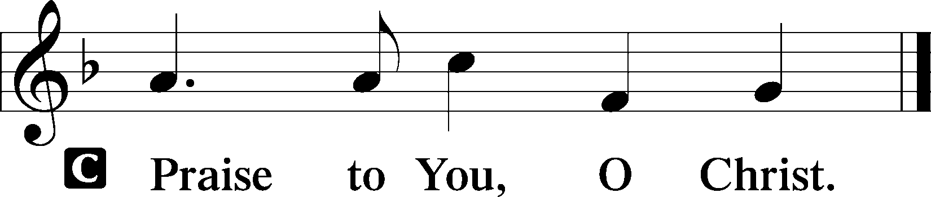

NICENE CREED

C **I believe in one God, the Father Almighty, maker of heaven and earth and of all things visible and invisible.**

**And in one Lord Jesus Christ, the only-begotten Son of God, begotten of His Father before all worlds, God of God, Light of Light, very God of very God, begotten, not made, being of one substance with the Father, by whom all things were made; who for us men and for our salvation came down from heaven and was incarnate by the Holy Spirit of the virgin Mary and was made man; and was crucified also for us under Pontius Pilate. He suffered and was buried. And the third day He rose again according to the Scriptures and ascended into heaven and sits at the right hand of the Father. And He will come again with glory to judge both the living and the dead, whose kingdom will have no end.**

**And I believe in the Holy Spirit, the Lord and giver of life, who proceeds from the Father and the Son, who with the Father and the Son together is worshiped and glorified, who spoke by the prophets. And I believe in one holy Christian and apostolic Church, I acknowledge one Baptism for the remission of sins, and I look for the resurrection of the dead and the life** T **of the world to come. Amen.**

Sit

547 THE LAMB

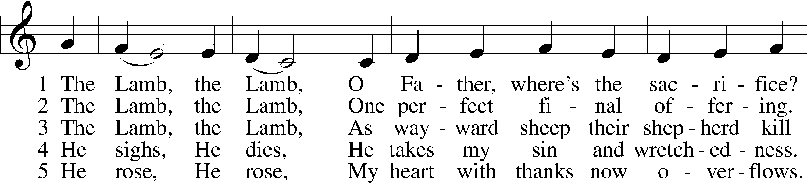

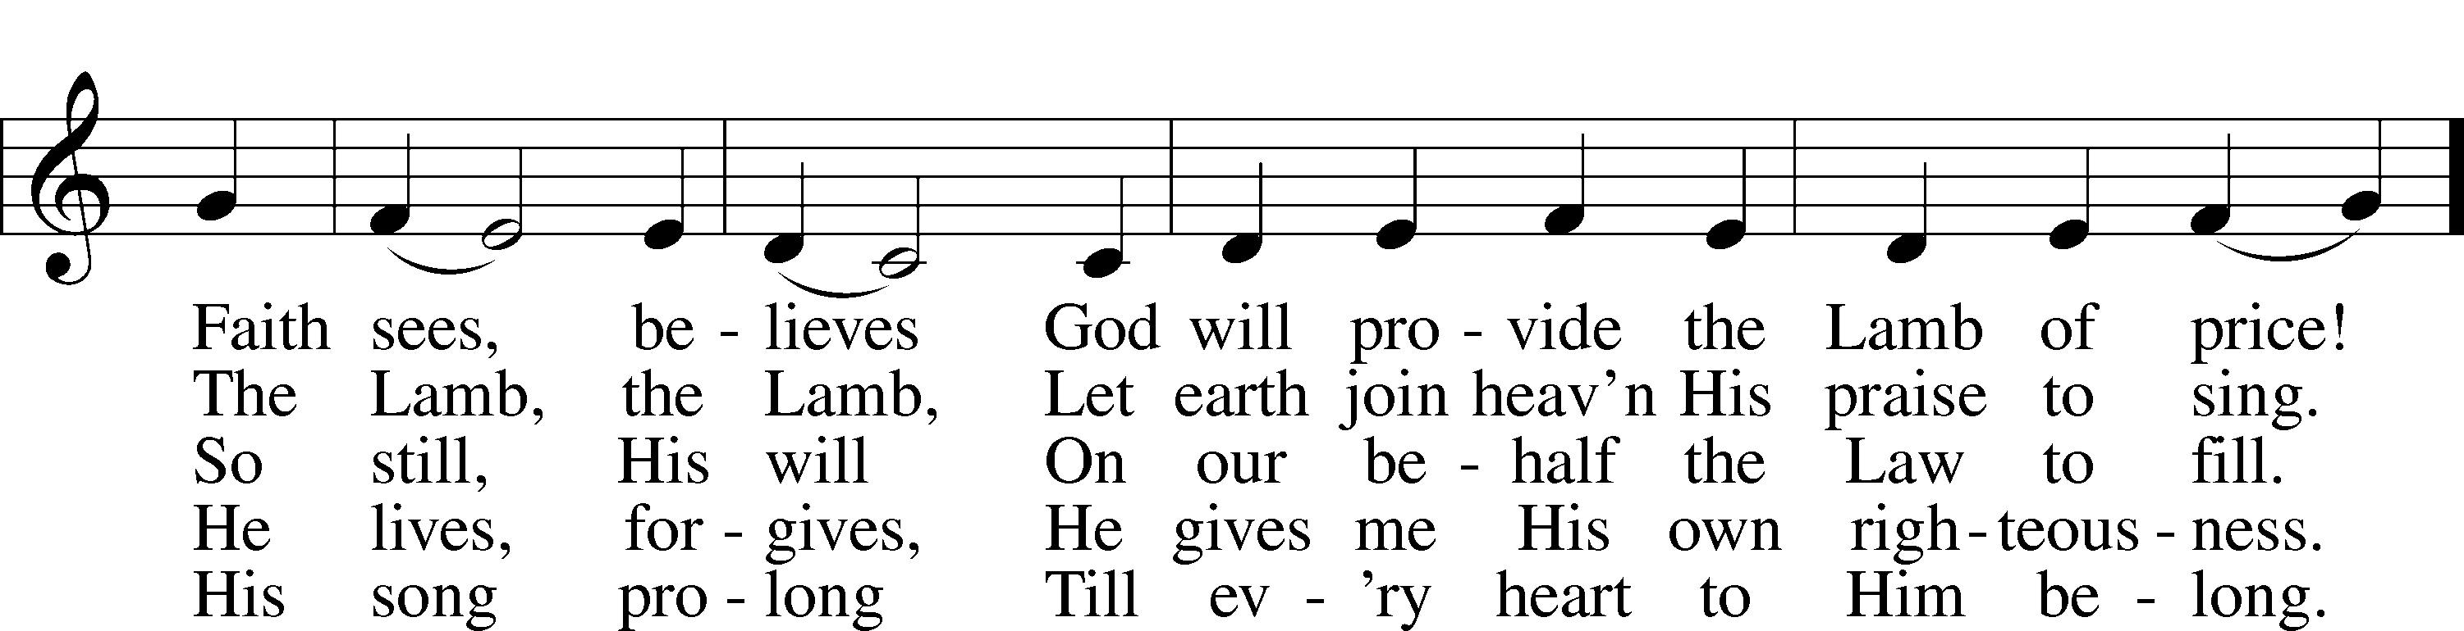

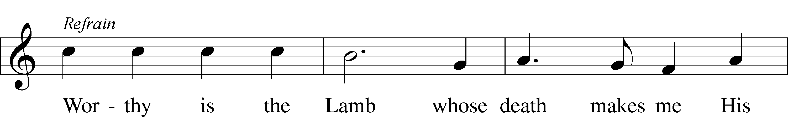



Text and tune: Gerald P. Coleman, 1953–2023  
Text and tune: © 1987 and 1997 MorningStar Music Publishers. Used by permission: LSB Hymn License no. 110004388

SERMON: “WORTHY IS THE LAMB WHO WAS SLAIN” *Revelation 5:1-12*

OFFERING

Stand

OFFERTORY LSB 159

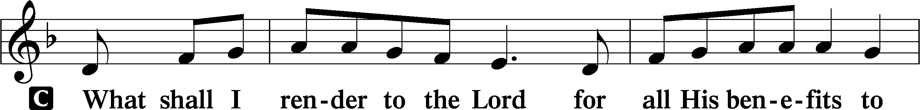

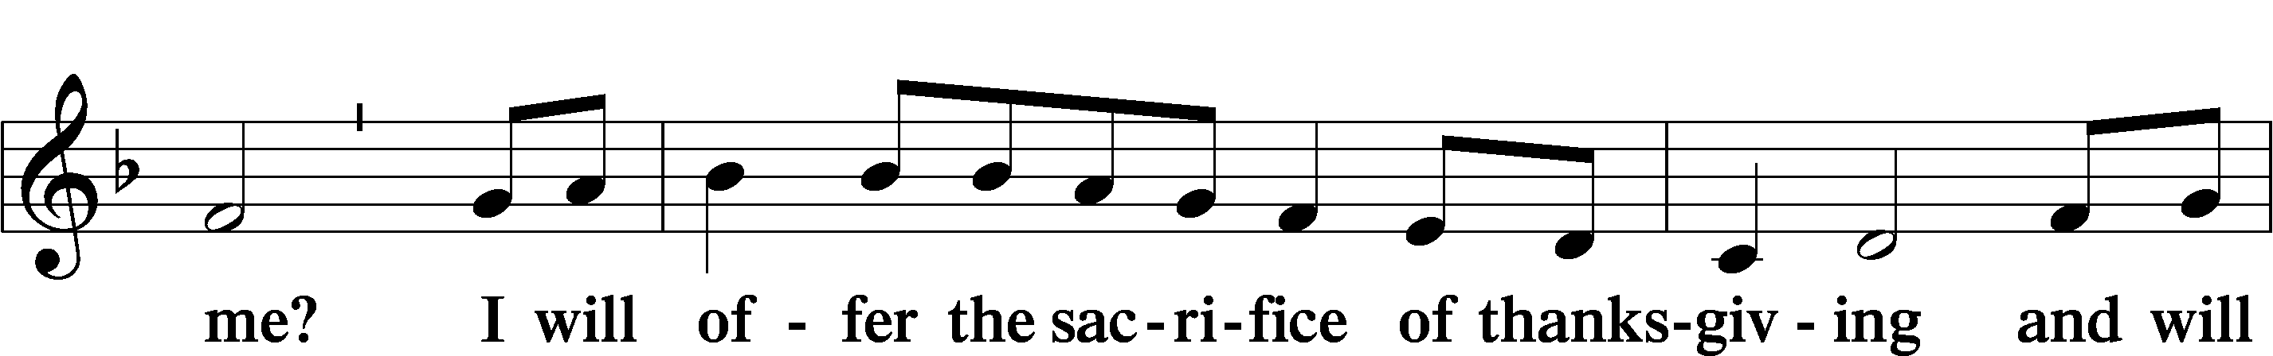

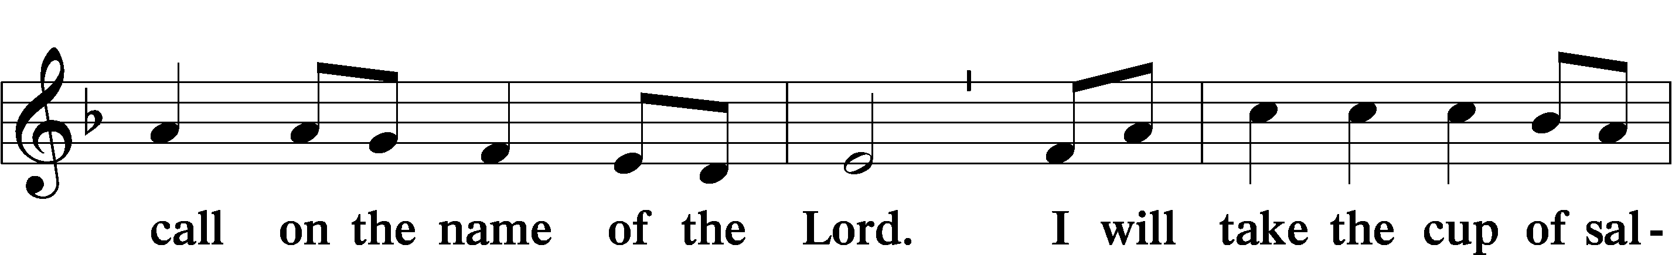

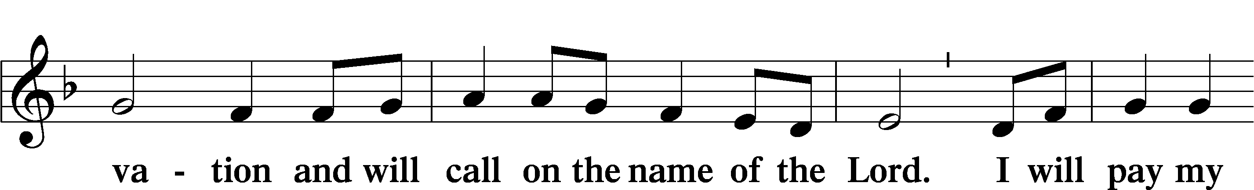

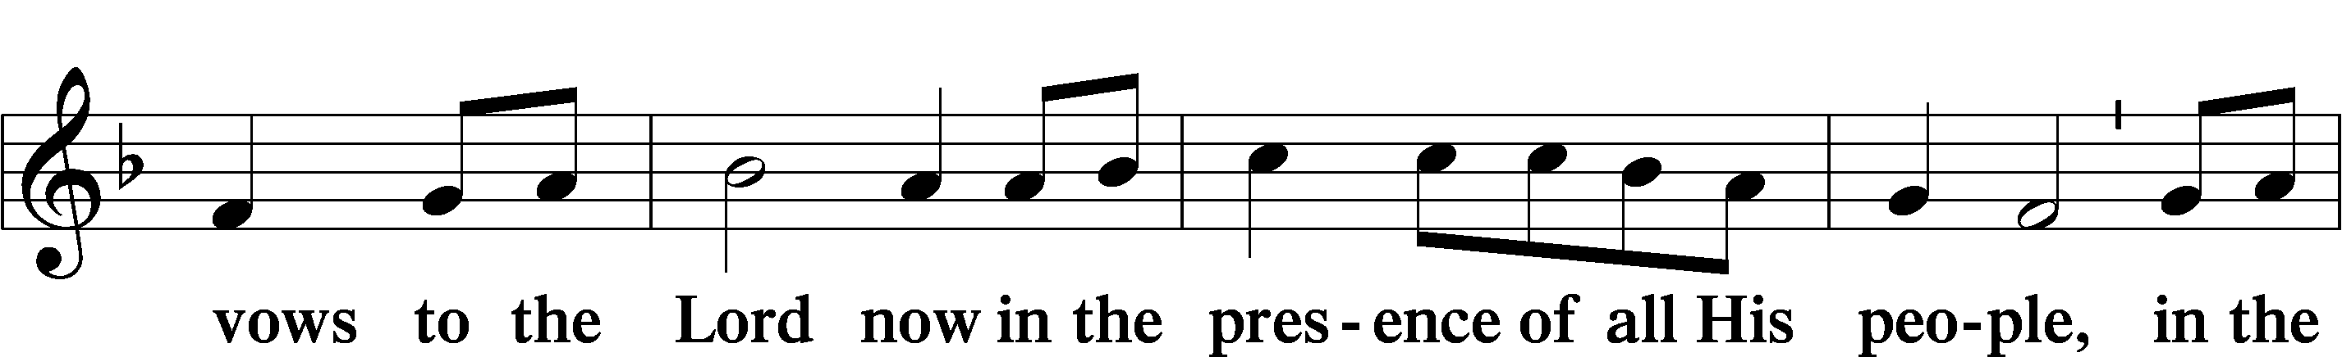

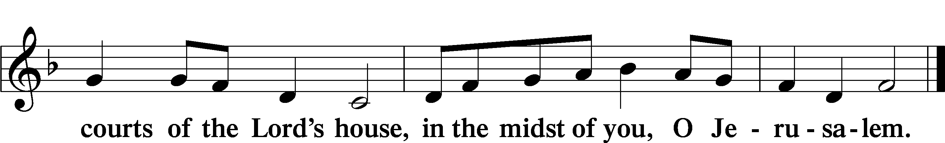

PRAYER OF THE CHURCH

# SERVICE OF THE SACRAMENT

PREFACE LSB 160

P The Lord be with you.



P Lift up your hearts.



P Let us give thanks to the Lord our God.

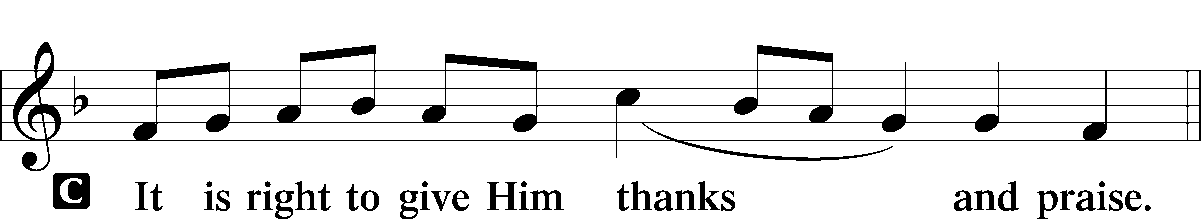

PROPER PREFACE (FULL)

P It is truly good, right, and salutary that we should at all times and in all places give thanks to You, holy Lord, almighty Father, everlasting God. And most especially are we bound to praise You on this day for the glorious resurrection of Your Son, Jesus Christ, the very Paschal Lamb, who was sacrificed for us and bore the sins of the world. By His dying He has destroyed death, and by His rising again He has restored to us everlasting life. Therefore with Mary Magdalene, Peter and John, and with all the witnesses of the resurrection, with angels and archangels, and with all the company of heaven we laud and magnify Your glorious name, evermore praising You and saying:

SANCTUS LSB 161

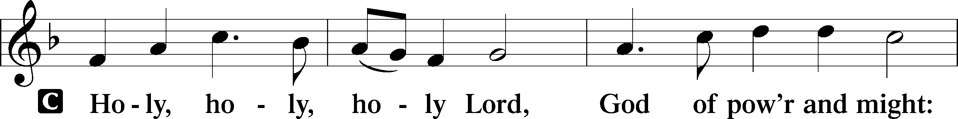

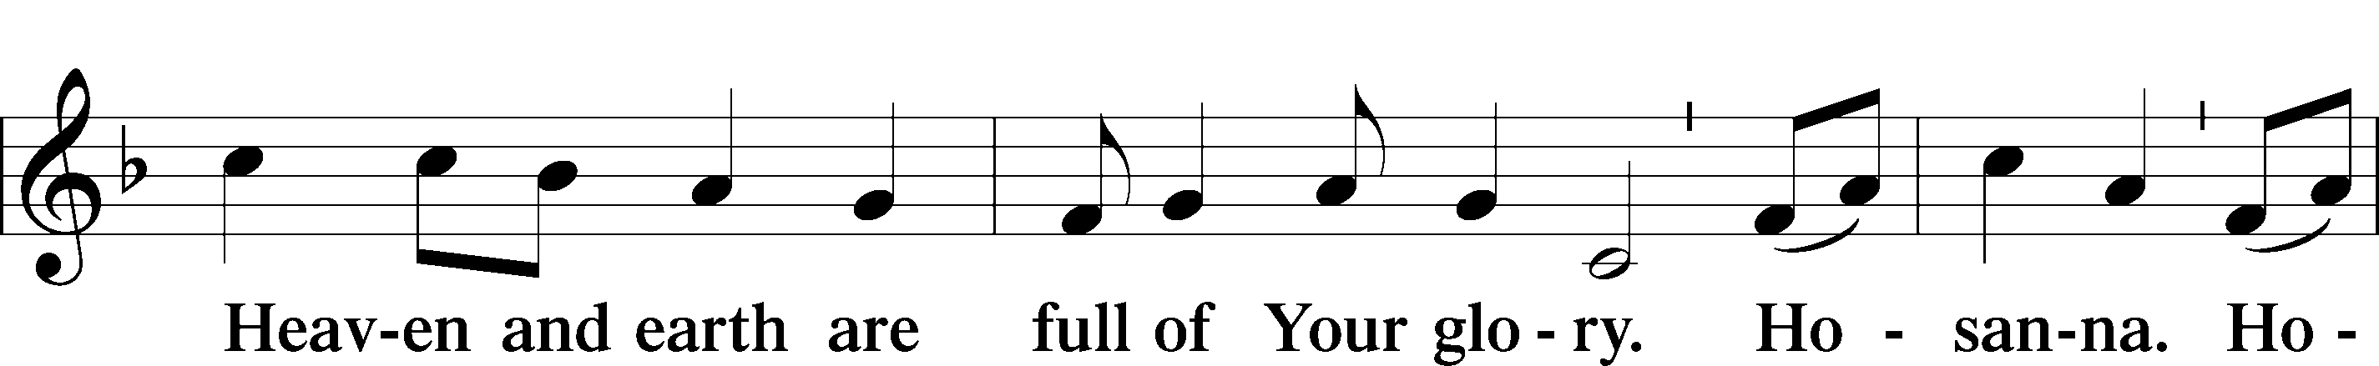

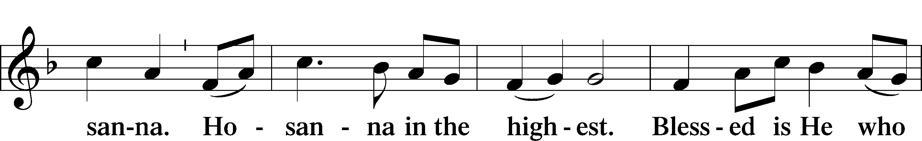

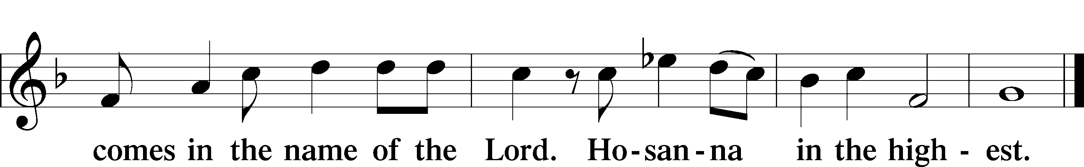

PRAYER OF THANKSGIVING LSB 161

P Blessed are You, Lord of heaven and earth, for You have had mercy on those whom You created and sent Your only-begotten Son into our flesh to bear our sin and be our Savior. With repentant joy we receive the salvation accomplished for us by the all-availing sacrifice of His body and His blood on the cross.

Gathered in the name and the remembrance of Jesus, we beg You, O Lord, to forgive, renew, and strengthen us with Your Word and Spirit. Grant us faithfully to eat His body and drink His blood as He bids us do in His own testament. Gather us together, we pray, from the ends of the earth to celebrate with all the faithful the marriage feast of the Lamb in His kingdom, which has no end. Graciously receive our prayers; deliver and preserve us. To You alone, O Father, be all glory, honor, and worship, with the Son and the Holy Spirit, one God, now and forever.

C **Amen.**

THE WORDS OF OUR LORD

P Our Lord Jesus Christ, on the night when He was betrayed, took bread, and when He had given thanks, He broke it and gave it to the disciples and said: “Take, eat; this is My T body, which is given for you. This do in remembrance of Me.”

In the same way also He took the cup after supper, and when He had given thanks, He gave it to them, saying: “Drink of it, all of you; this cup is the new testament in My T blood, which is shed for you for the forgiveness of sins. This do, as often as you drink it, in remembrance of Me.”

PROCLAMATION OF CHRIST

P As often as we eat this bread and drink this cup, we proclaim the Lord’s death until He comes.

C **Amen. Come, Lord Jesus.**

P O Lord Jesus Christ, only Son of the Father, in giving us Your body and blood to eat and to drink, You lead us to remember and confess Your holy cross and passion, Your blessed death, Your rest in the tomb, Your resurrection from the dead, Your ascension into heaven, and Your coming for the final judgment. So remember us in Your kingdom and teach us to pray:

LORD’S PRAYER

C **Our Father who art in heaven, hallowed be Thy name, Thy kingdom come, Thy will be done on earth as it is in heaven; give us this day our daily bread; and forgive us our trespasses as we forgive those who trespass against us; and lead us not into temptation, but deliver us from evil. For Thine is the kingdom and the power and the glory forever and ever. Amen.**

PAX DOMINI LSB 163

P The peace of the Lord be with you always.



AGNUS DEI LSB 163

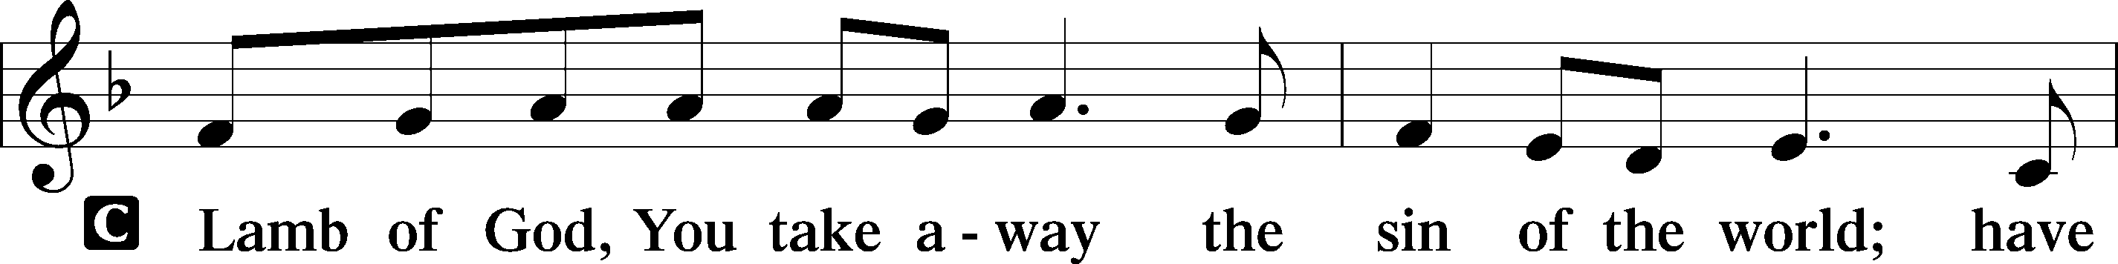

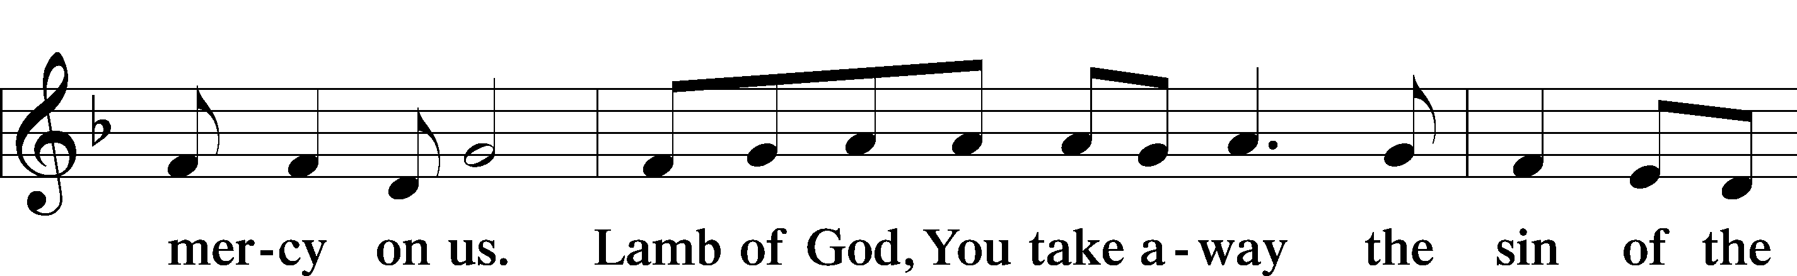

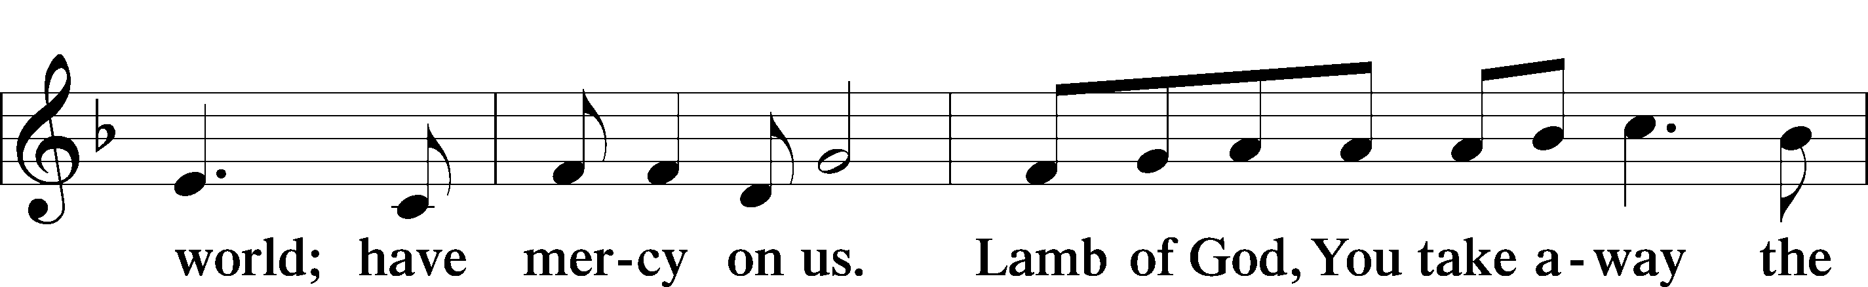

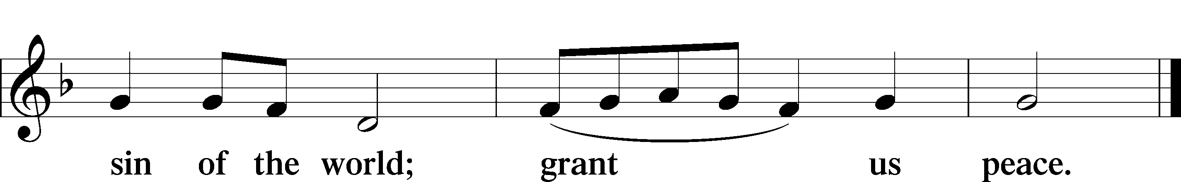

Sit

DISTRIBUTION

525 CROWN HIM WITH MANY CROWNS

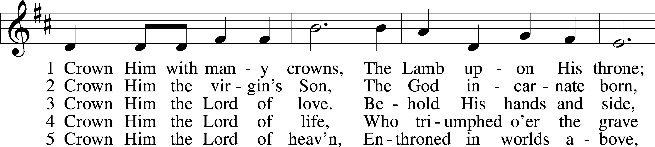

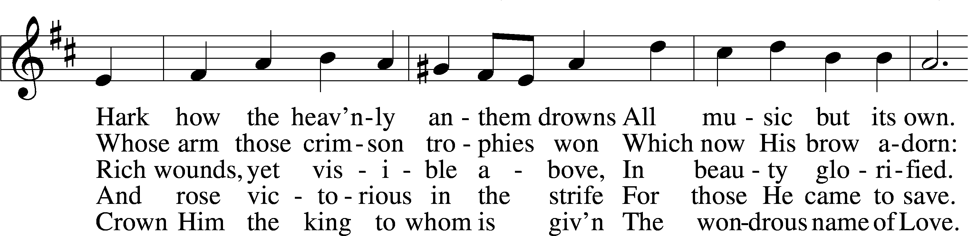

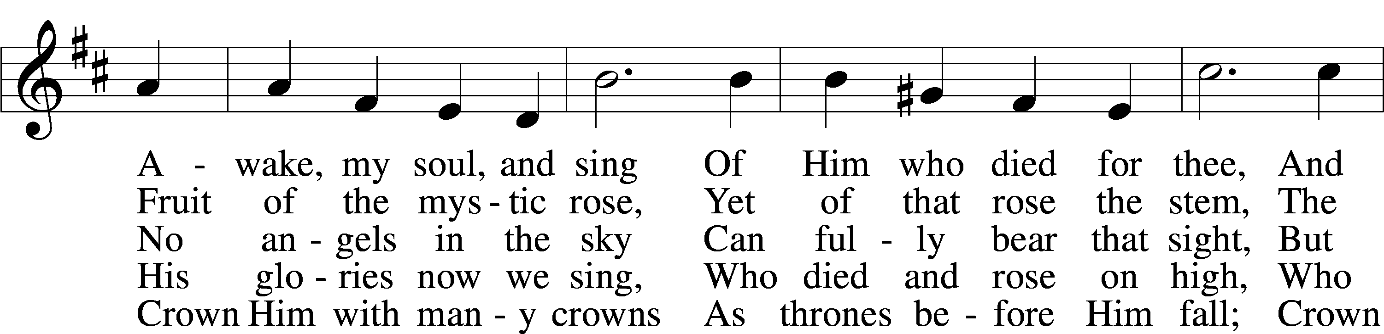

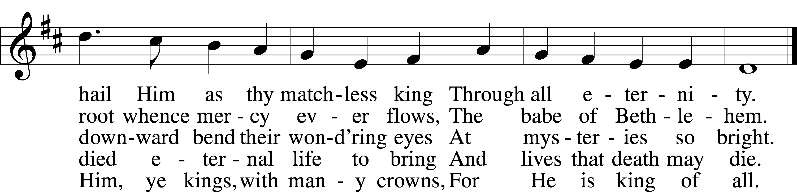

Text (sts. 1–3, 5): Matthew Bridges, 1800–94, alt.; (st. 4): Godfrey Thring, 1823–1903 Tune: George J. Elvey, 1816–93 Text and tune: Public domain

633 AT THE LAMB’S HIGH FEAST WE SING sts. 1–5

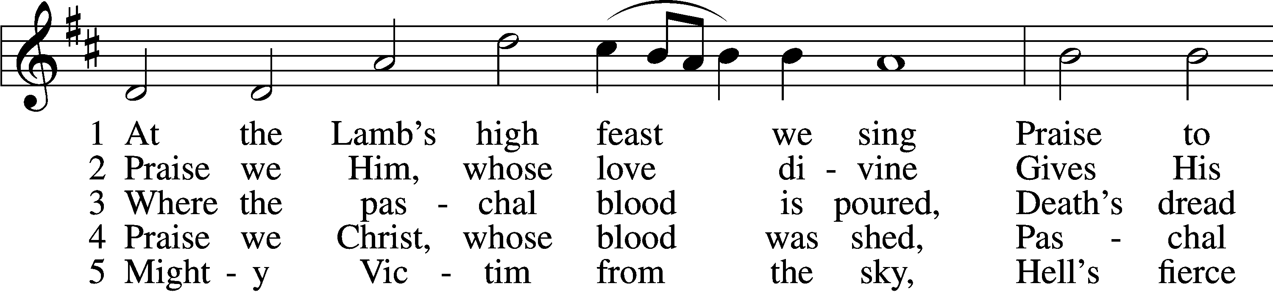

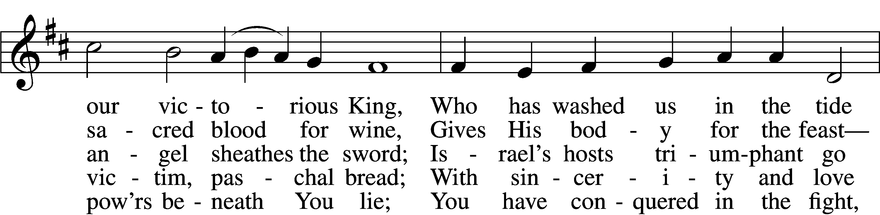

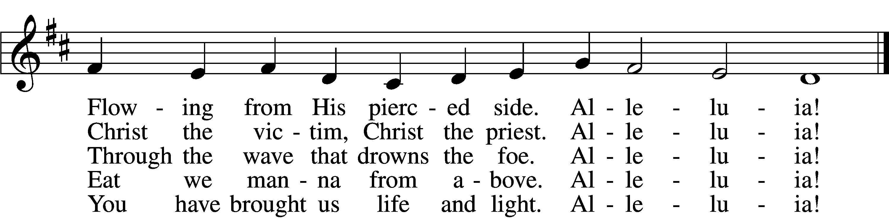

Text: Latin, c. 5th–10th cent.; tr. Robert Campbell, 1814–68, alt. Tune: Kirchengeseng, 1566, Ivancice Text and tune: Public domain

818 IN THEE IS GLADNESS

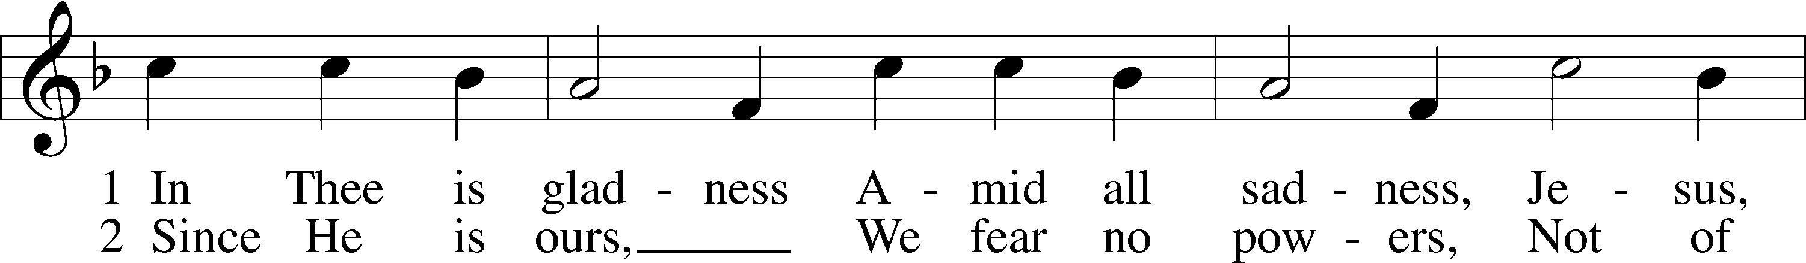

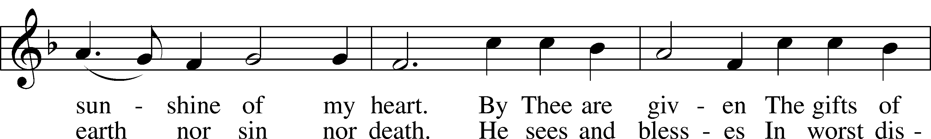

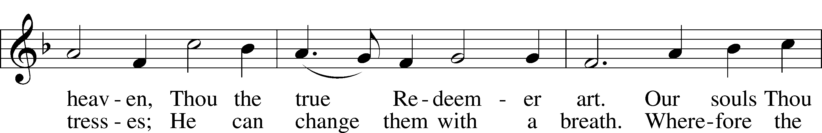

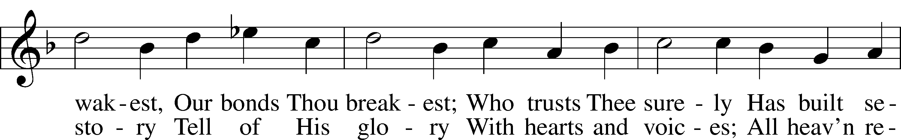

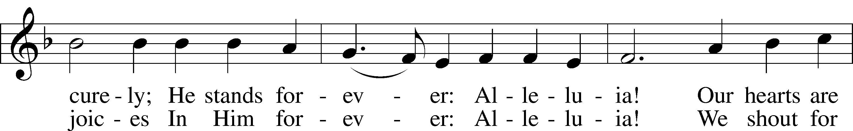

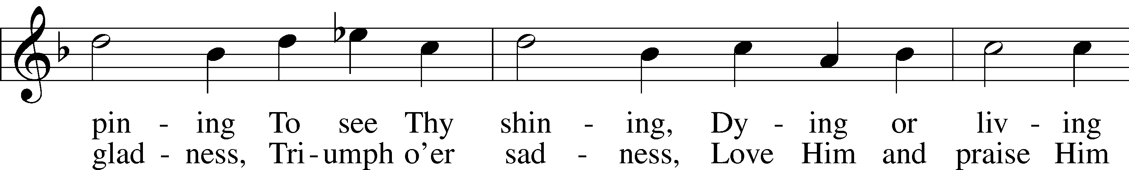

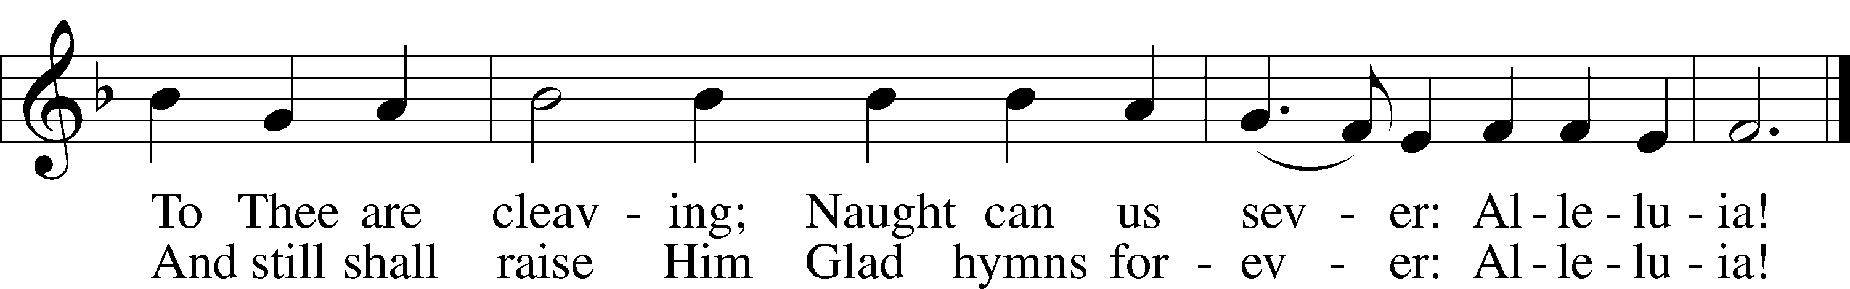

Text: Johann Lindemann, 1549–1631; tr. Catherine Winkworth, 1827–78, alt.  
Tune: Giovanni Giacomo Gastoldi, c. 1556–c. 1622  
Text and tune: Public domain

Stand

THANK THE LORD LSB 164

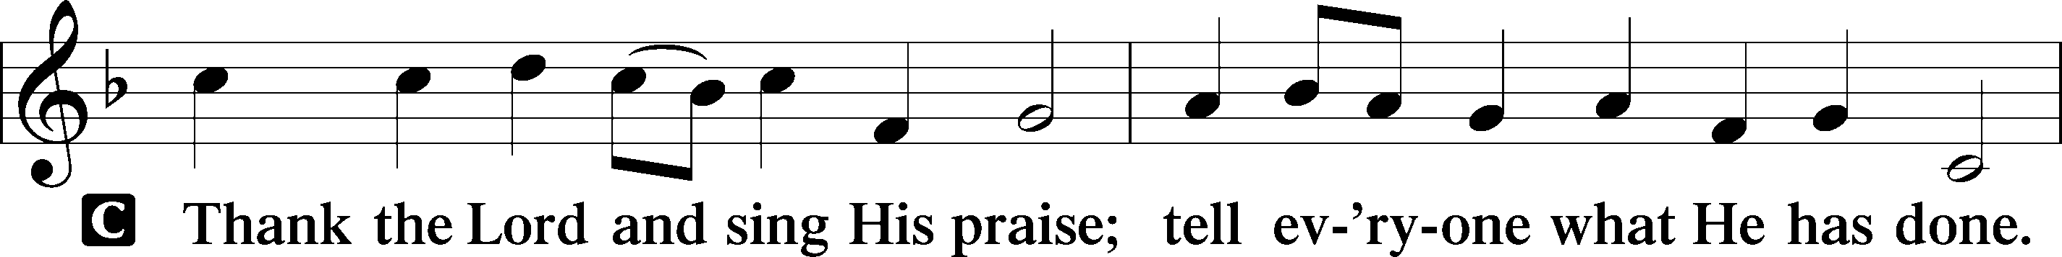

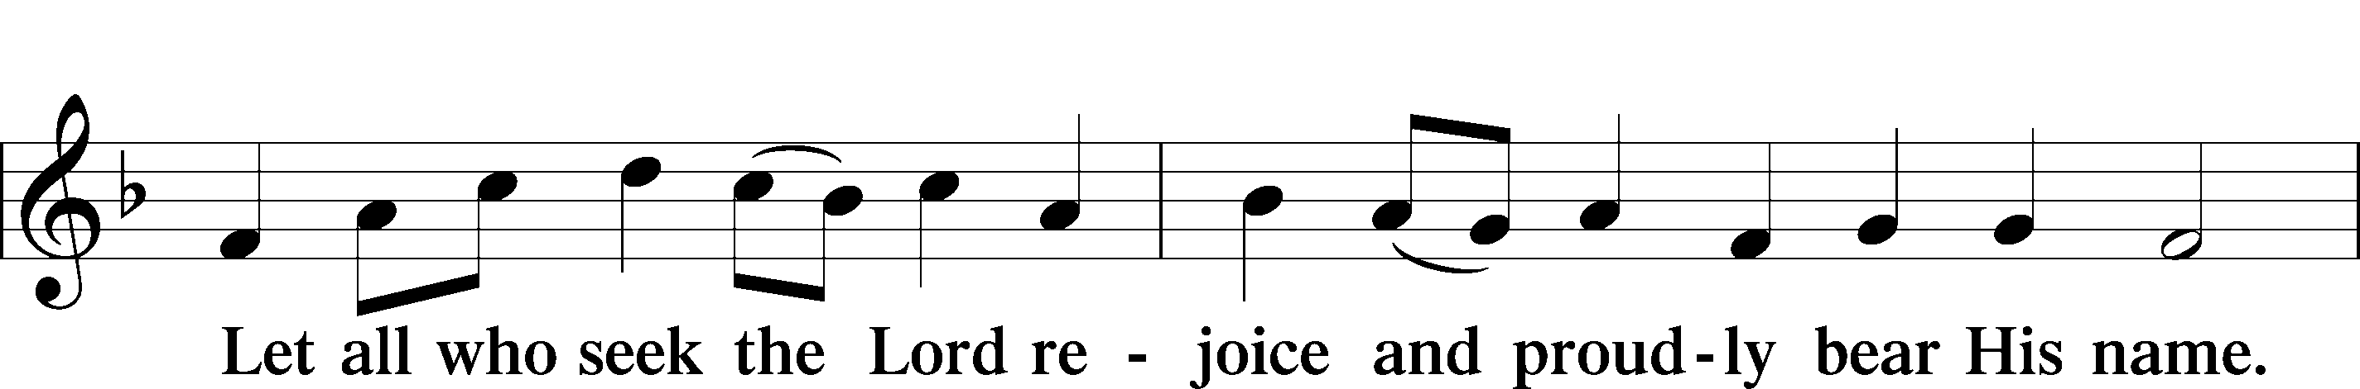

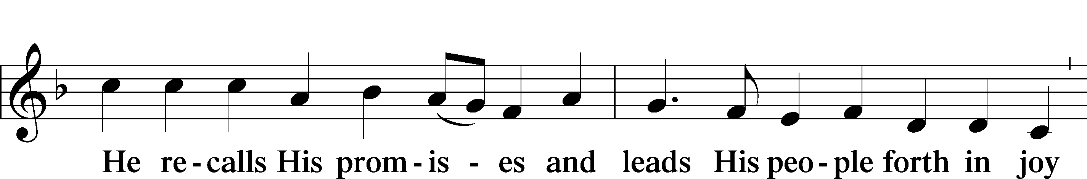

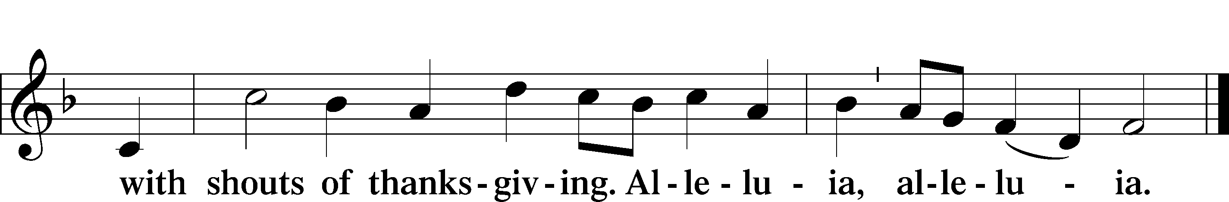

POST-COMMUNION COLLECT

A Let us pray.

We give thanks to You, almighty God, that You have refreshed us through this salutary gift, and we implore You that of Your mercy You would strengthen us through the same in faith toward You and in fervent love toward one another; through Jesus Christ, Your Son, our Lord, who lives and reigns with You and the Holy Spirit, one God, now and forever.



BENEDICTION LSB 166

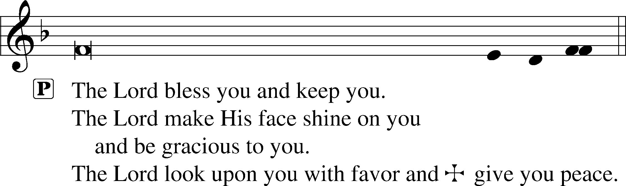



484 MAKE SONGS OF JOY

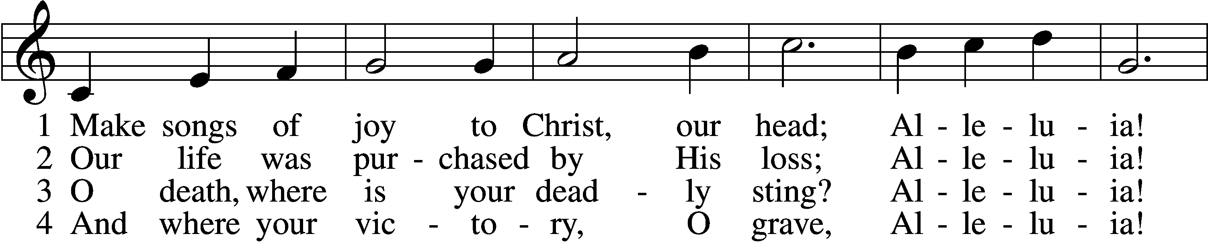

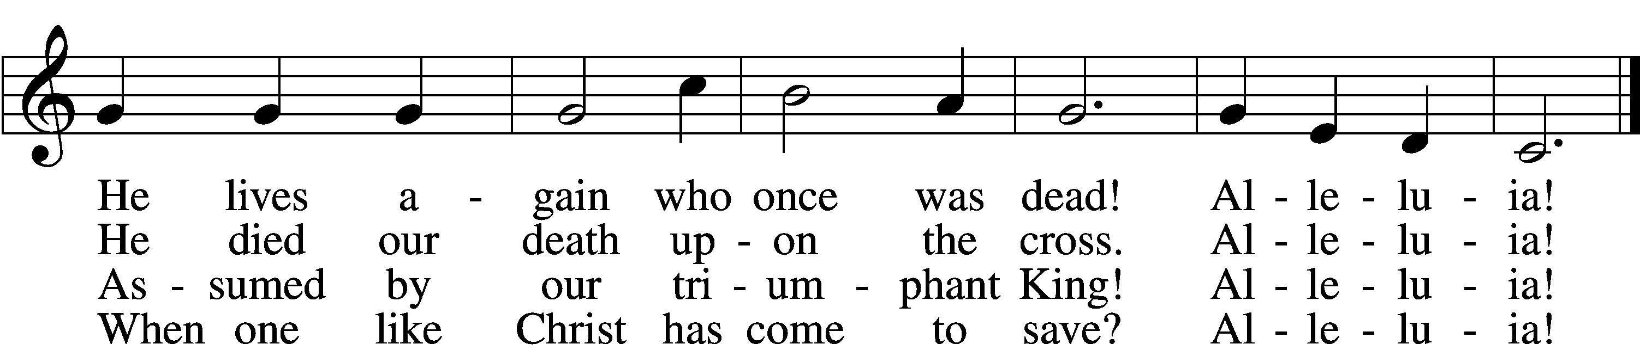

5 Behold, the tyrants, one and all,  
 Alleluia!  
Before our mighty Savior fall!  
 Alleluia!

D 6 For this be praised the Son who rose,  
 Alleluia!  
The Father, and the Holy Ghost!  
 Alleluia!

Text: Juraj Tranovský, 1591–1637; tr. Jaroslav J. Vajda, 1919–2008 Tune: Velká Partitúra, 1936, ed. Juraj Chorvát Text: © 1978 Lutheran Book of Worship. Used by permission: LSB Hymn License no. 110004388 Tune: Public domain

ACKNOWLEDGMENTS

Divine Service, Setting One from Lutheran Service Book

Unless otherwise indicated, Scripture quotations are from the ESV® Bible (The Holy Bible, English Standard Version®), copyright © 2001 by Crossway, a publishing ministry of Good News Publishers. Used by permission. All rights reserved.

Created by Lutheran Service Builder © 2025 Concordia Publishing House.