**St. Michael and All Angels**

**September 29, 2024**

“And the great dragon was thrown down, that ancient serpent, who is called the devil and Satan, the deceiver of the whole world”

**PEACE LUTHERAN CHURCH**

1451 Ebenezer Rd + Cincinnati, OH 45233 + 513-941-5177

[**www.peacechurchlink.com**](http://www.peacechurchlink.com)

**About This Service**

St. Michael and All Angels commemorates the great battle in heaven between Satan and his evil angels and St. Michael and the angels of the Lord. The readings for this day describe how the Lord used Michael and the angels to deliver His people from the accusations of Satan. Because Jesus took all of Satan’s accusations against us upon Himself when He went to the cross, Satan has nothing more to say to the Lord about us or about our sins. Every evil deed, every sin, every impure thought or intention was placed upon Jesus. Now Satan is not only silenced but is cast down from heaven, never more to stand before the Lord to deliver slander or accusation against His people.

The time before the Divine Service begins is a time for meditation and prayer. It’s a time for us to prepare our hearts and minds to hear God’s Word and receive His gifts. Therefore, we ask that you would please remain silent as you enter the sanctuary out of reverence for God and respect for one another.

**Are My Children Welcome?**

In God’s eyes we’re all children. Yes, your little ones are more than welcome! If your child needs a little extra room to “make a joyful noise” you’re welcome to take them out of the sanctuary and into the narthex or the Fellowship Hall.

**How Do I Become a Lutheran Christian?**

If you’re exploring the Lutheran Church, Pastor Shaw would be happy to offer guidance or answer your questions. Our website peacechurchlink.com is also a good resource. When you’re ready, there’s a formal process of reading, study, and prayer that culminates in being received into the Lutheran Church.

549 All Hail the Power of Jesus’ Name sts. 1–5

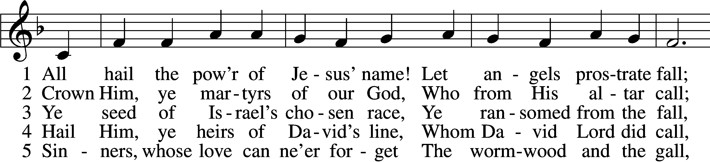

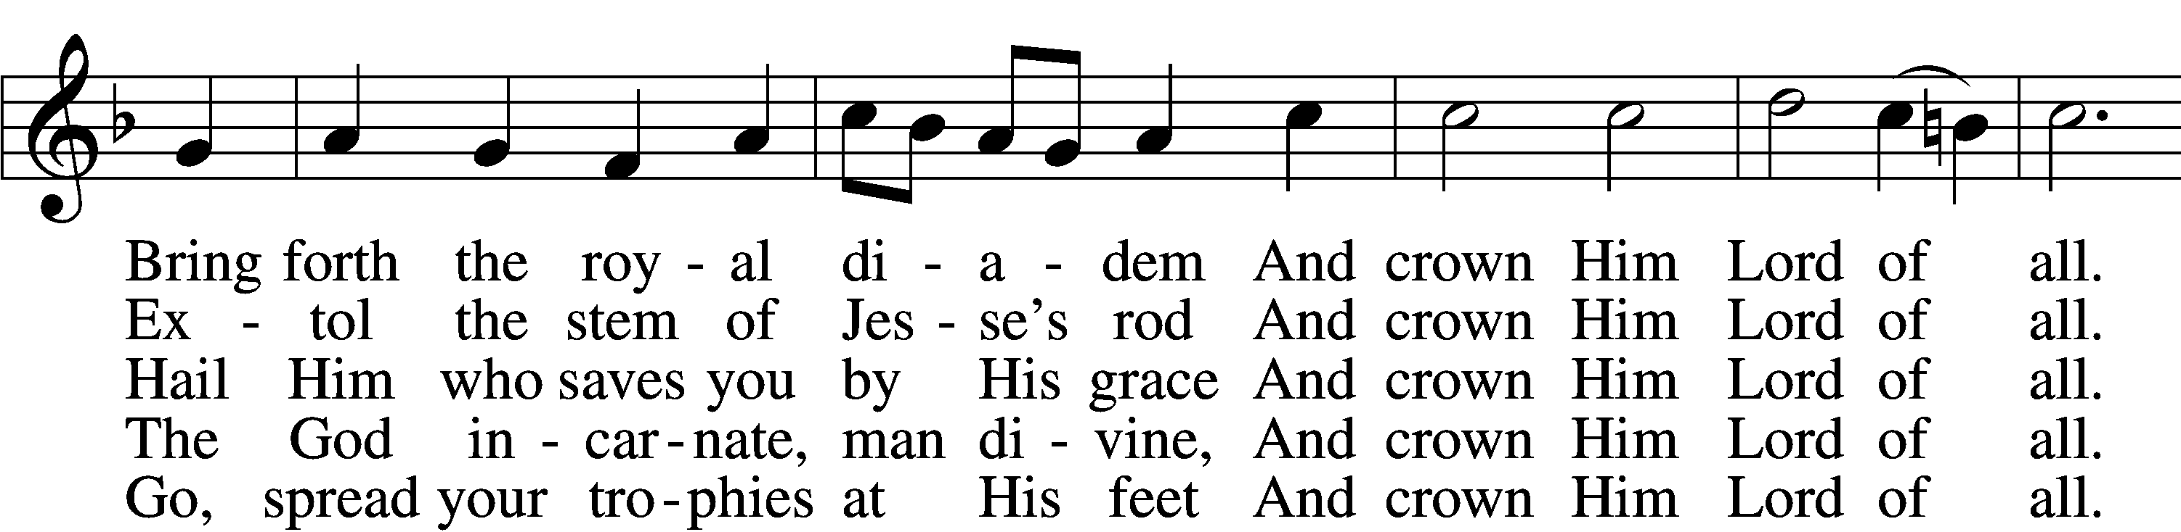

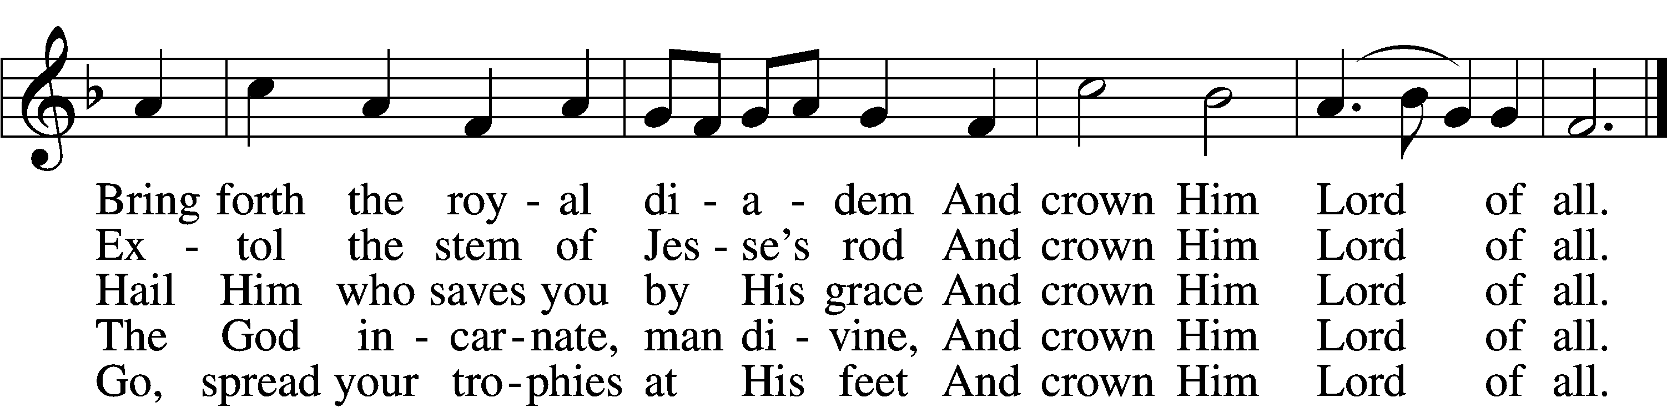

Text: Edward Perronet, 1726–92, alt. Tune: Oliver Holden, 1765–1844vText and tune: Public domain

# Confession and Absolution

Stand

The sign of the cross may be made by all in remembrance of their Baptism.

P In the name of the Father and of the T Son and of the Holy Spirit.

C **Amen.**

P If we say we have no sin, we deceive ourselves, and the truth is not in us.

C **But if we confess our sins, God, who is faithful and just, will forgive our sins and cleanse us from all unrighteousness.**

Silence for reflection on God’s Word and for self-examination.

P Let us then confess our sins to God our Father.

C **Most merciful God, we confess that we are by nature sinful and unclean. We have sinned against You in thought, word, and deed, by what we have done and by what we have left undone. We have not loved You with our whole heart; we have not loved our neighbors as ourselves. We justly deserve Your present and eternal punishment. For the sake of Your Son, Jesus Christ, have mercy on us. Forgive us, renew us, and lead us, so that we may delight in Your will and walk in Your ways to the glory of Your holy name. Amen.**

P Almighty God in His mercy has given His Son to die for you and for His sake forgives you all your sins. As a called and ordained servant of Christ, and by His authority, I therefore forgive you all your sins in the name of the Father and of the T Son and of the Holy Spirit.

C **Amen.**

# Service of the Word

Introit Psalm 103:20–22; antiphon: v. 1

Bless the Lord, O my soul,  
 **and all that is within me, bless his holy name!**  
Bless the Lord, O you his angels,  
 **you mighty ones who do his word, obeying the voice of his word!**  
Bless the Lord, all his hosts,  
 **his ministers, who do his will!**Bless the Lord, all his works, in all places of his dominion.  
 **Bless the Lord, O my soul!  
Glory be to the Father and to the Son**  
 **and to the Holy Spirit;**  
**as it was in the beginning,**  
 **is now, and will be forever. Amen.**  
Bless the Lord, O my soul,  
 **and all that is within me, bless his holy name!**

Kyrie LSB 168

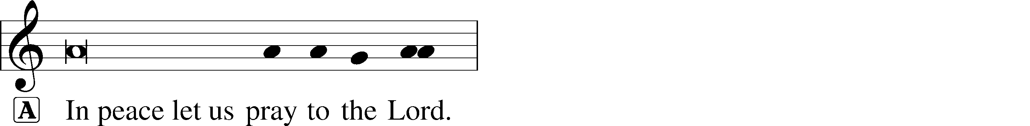

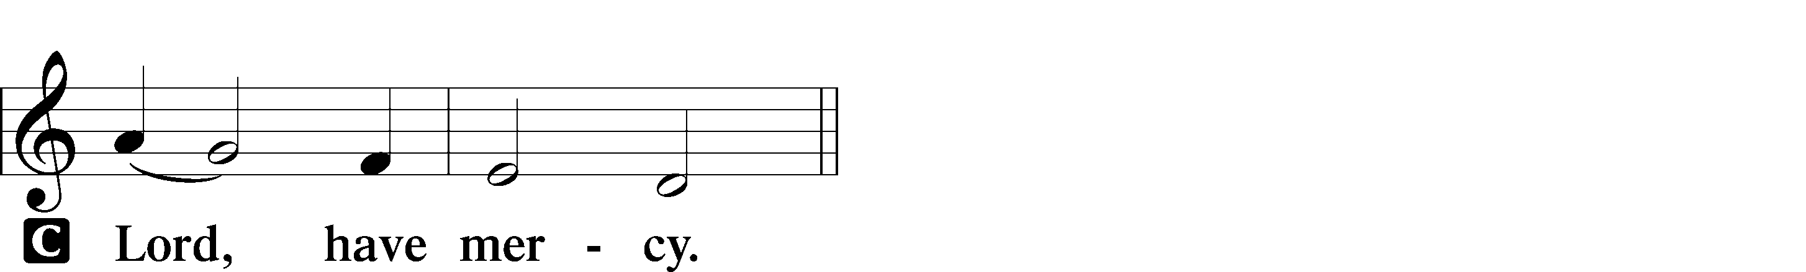

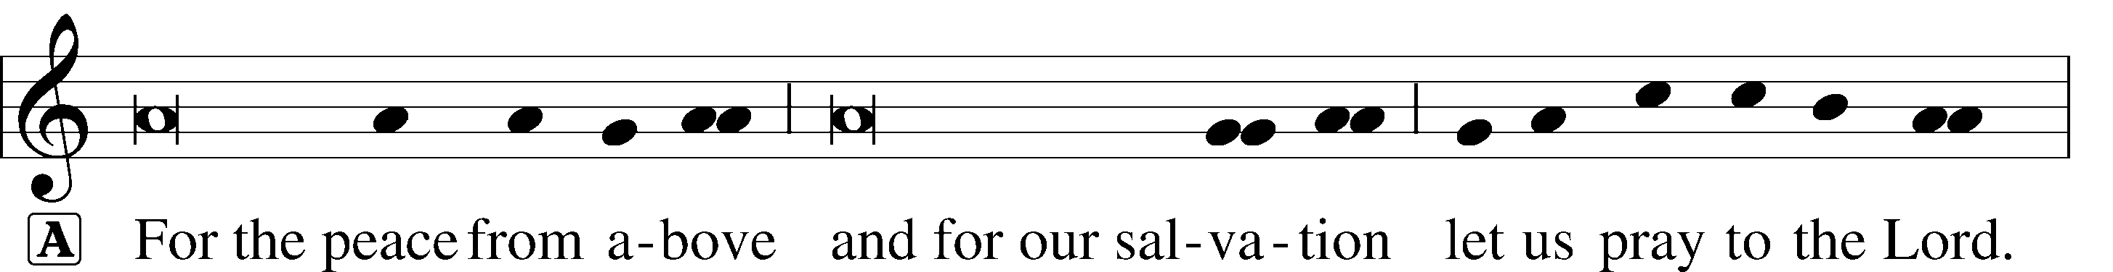

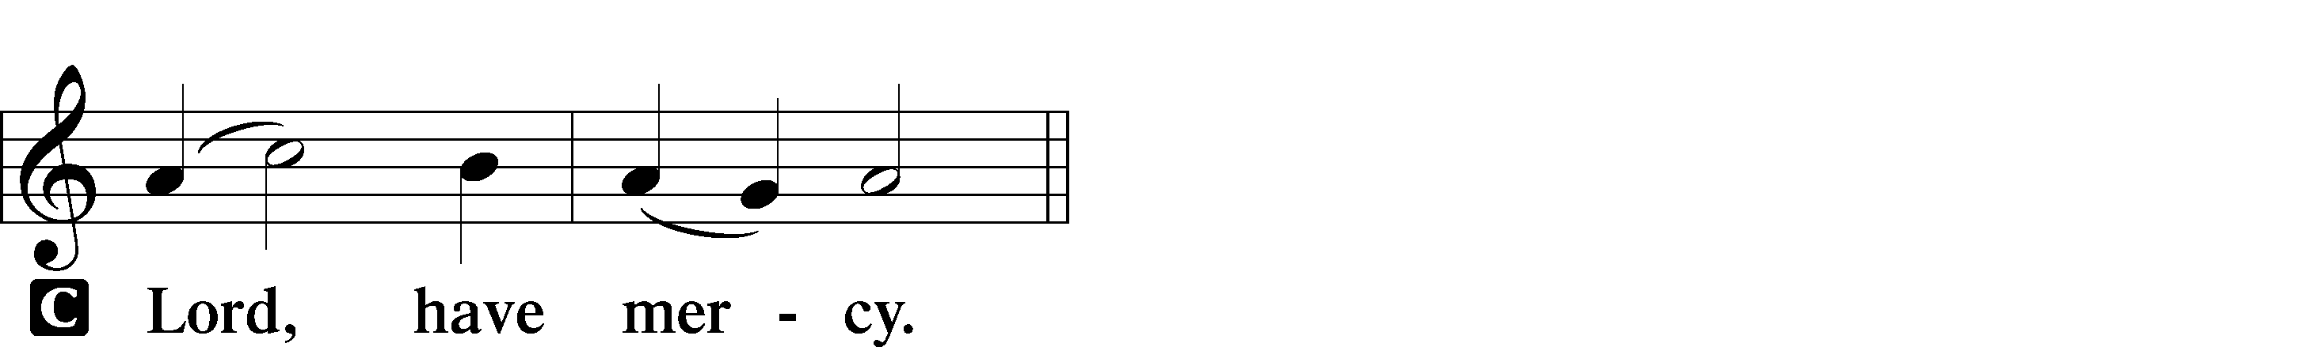

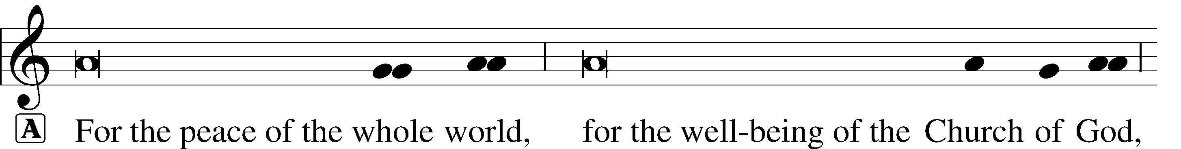

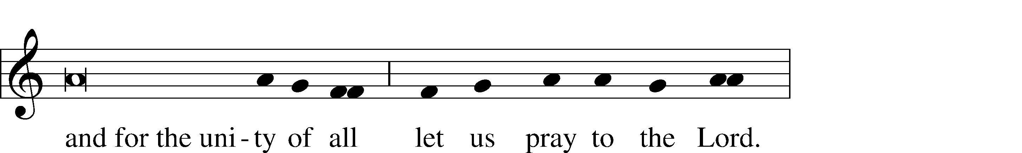

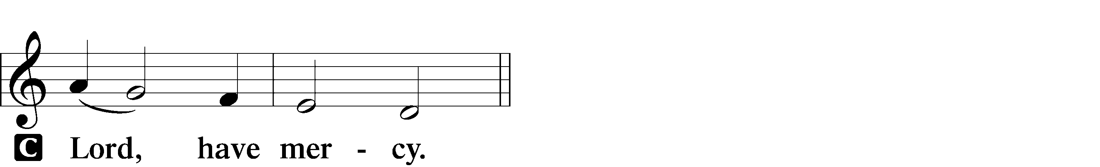

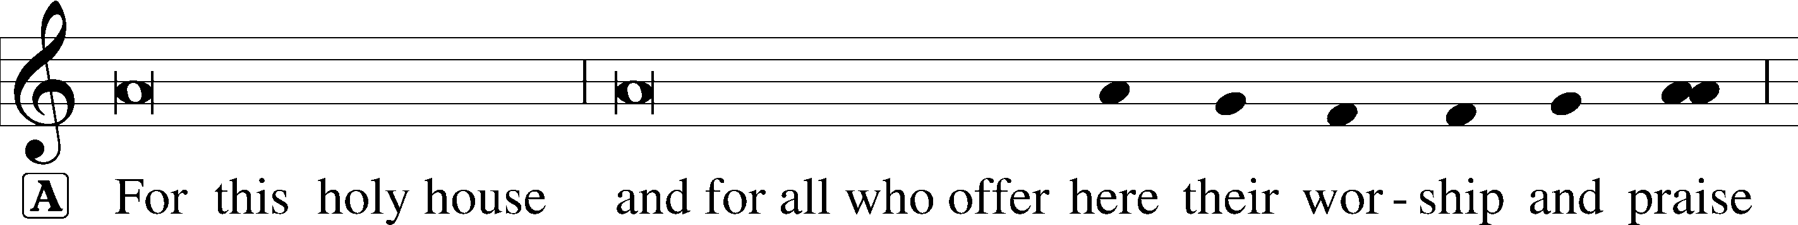



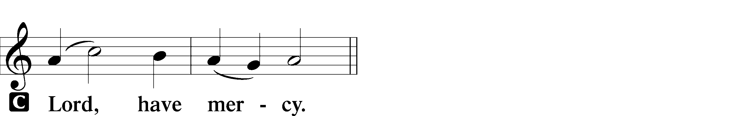





Salutation and Collect of the Day

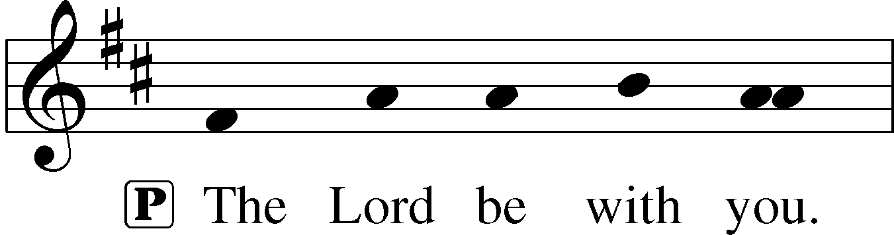

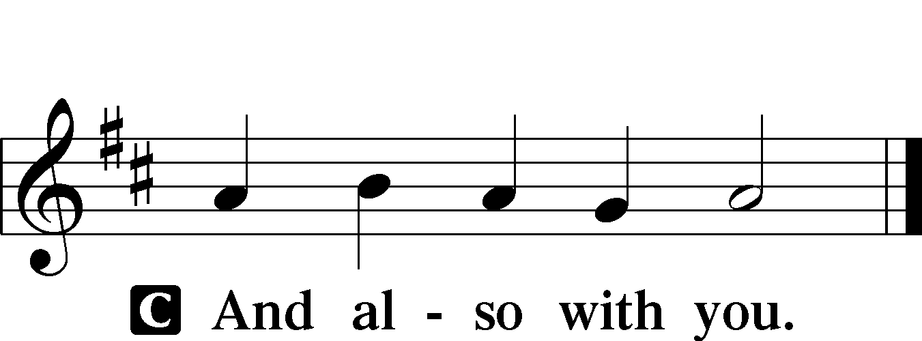

P Let us pray.

Everlasting God, You have ordained and constituted the service of angels and men in a wonderful order. Mercifully grant that, as Your holy angels always serve and worship You in heaven, so by Your appointment they may also help and defend us here on earth; through Your Son, Jesus Christ, our Lord, who lives and reigns with You and the Holy Spirit, one God, now and forever.

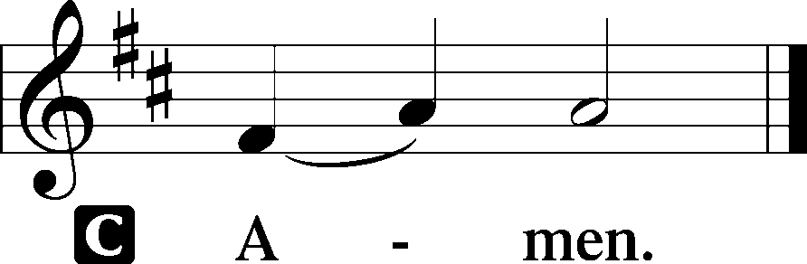

Sit

Old Testament Reading Daniel 10:10–14; 12:1–3

10And behold, a hand touched me and set me trembling on my hands and knees. 11And he said to me, “O Daniel, man greatly loved, understand the words that I speak to you, and stand upright, for now I have been sent to you.” And when he had spoken this word to me, I stood up trembling. 12Then he said to me, “Fear not, Daniel, for from the first day that you set your heart to understand and humbled yourself before your God, your words have been heard, and I have come because of your words. 13The prince of the kingdom of Persia withstood me twenty-one days, but Michael, one of the chief princes, came to help me, for I was left there with the kings of Persia, 14and came to make you understand what is to happen to your people in the latter days. For the vision is for days yet to come. . . .”

1“At that time shall arise Michael, the great prince who has charge of your people. And there shall be a time of trouble, such as never has been since there was a nation till that time. But at that time your people shall be delivered, everyone whose name shall be found written in the book. 2And many of those who sleep in the dust of the earth shall awake, some to everlasting life, and some to shame and everlasting contempt. 3And those who are wise shall shine like the brightness of the sky above; and those who turn many to righteousness, like the stars forever and ever.”

A This is the Word of the Lord.

C **Thanks be to God.**

Epistle Revelation 12:7–12

7Now war arose in heaven, Michael and his angels fighting against the dragon. And the dragon and his angels fought back, 8but he was defeated and there was no longer any place for them in heaven. 9And the great dragon was thrown down, that ancient serpent, who is called the devil and Satan, the deceiver of the whole world—he was thrown down to the earth, and his angels were thrown down with him. 10And I heard a loud voice in heaven, saying, “Now the salvation and the power and the kingdom of our God and the authority of his Christ have come, for the accuser of our brothers has been thrown down, who accuses them day and night before our God. 11And they have conquered him by the blood of the Lamb and by the word of their testimony, for they loved not their lives even unto death. 12Therefore, rejoice, O heavens and you who dwell in them! But woe to you, O earth and sea, for the devil has come down to you in great wrath, because he knows that his time is short!”

A This is the Word of the Lord.

C **Thanks be to God.**

Stand

Alleluia and Verse LSB 173

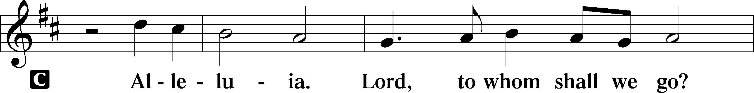

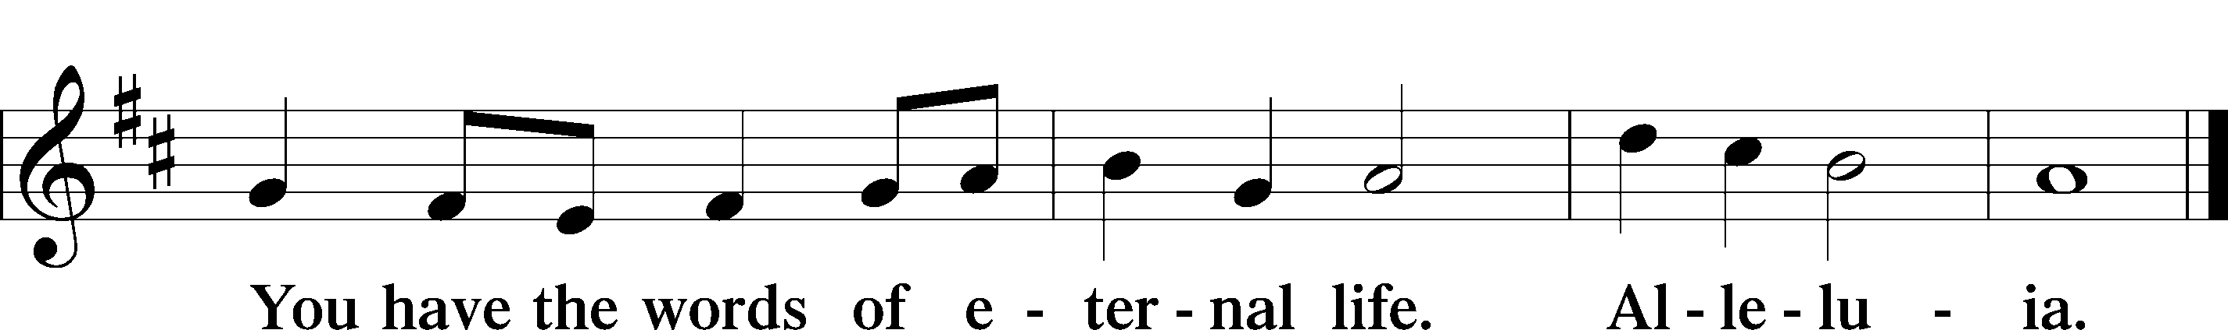

Holy Gospel Luke 10:17–20

P The Holy Gospel according to St. Luke, the tenth chapter.

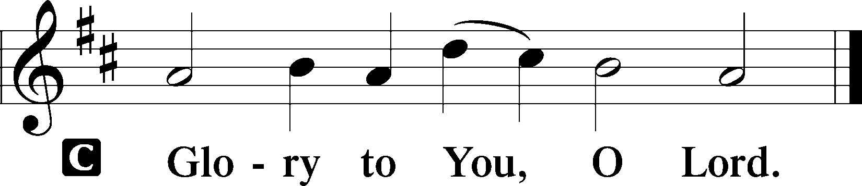

17The seventy-two returned with joy, saying, “Lord, even the demons are subject to us in your name!” 18And he said to them, “I saw Satan fall like lightning from heaven. 19Behold, I have given you authority to tread on serpents and scorpions, and over all the power of the enemy, and nothing shall hurt you. 20Nevertheless, do not rejoice in this, that the spirits are subject to you, but rejoice that your names are written in heaven.”

P This is the Gospel of the Lord.

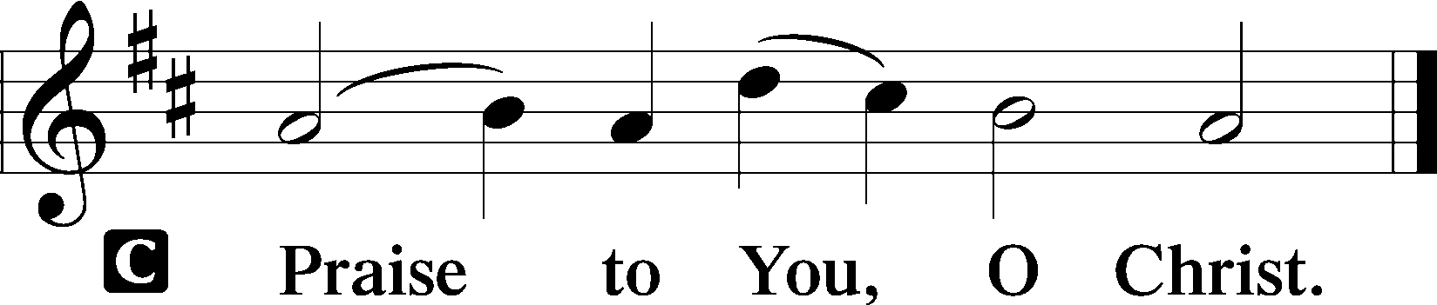

Apostles’ Creed

C **I believe in God, the Father Almighty, maker of heaven and earth.**

**And in Jesus Christ, His only Son, our Lord, who was conceived by the Holy Spirit, born of the virgin Mary, suffered under Pontius Pilate, was crucified, died and was buried. He descended into hell. The third day He rose again from the dead. He ascended into heaven and sits at the right hand of God the Father Almighty. From thence He will come to judge the living and the dead.**

**I believe in the Holy Spirit, the holy Christian Church, the communion of saints, the forgiveness of sins, the resurrection of the body, and the life** T **everlasting. Amen.**

Sit

**508 The Day Is Surely Drawing Near** *sts. 1–5*

6 May Christ our intercessor be  
 And through His blood and merit  
Read from His book that we are free  
 With all who life inherit.  
Then we shall see Him face to face,  
With all His saints in that blest place  
 Which He has purchased for us.

Text: Bartholomäus Ringwaldt, 1532–99; tr. Philip A. Peter, 1832–1919, alt.

Tune: Geistliche Lieder auffs new gebessert, 1535, Wittenberg, ed. Joseph Klug Text and tune: Public domain

Sermon: “The War in Heaven” *Revelation 12:7–12*

Offering

*Stand*

Offertory LSB 176

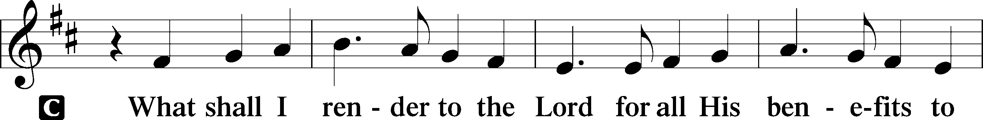

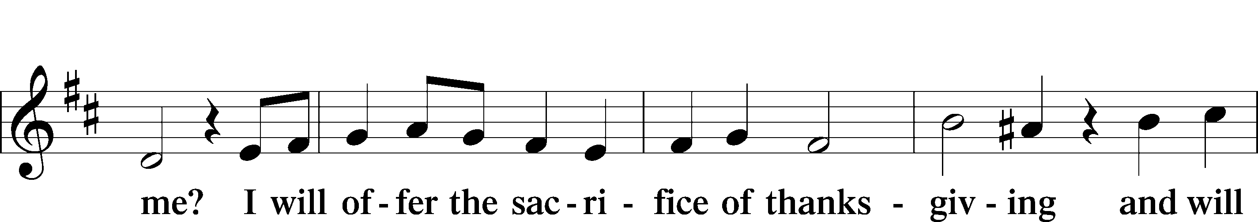

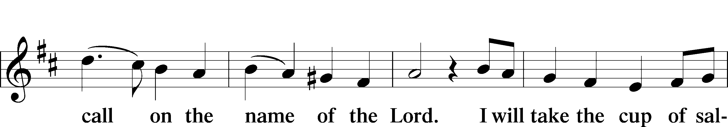

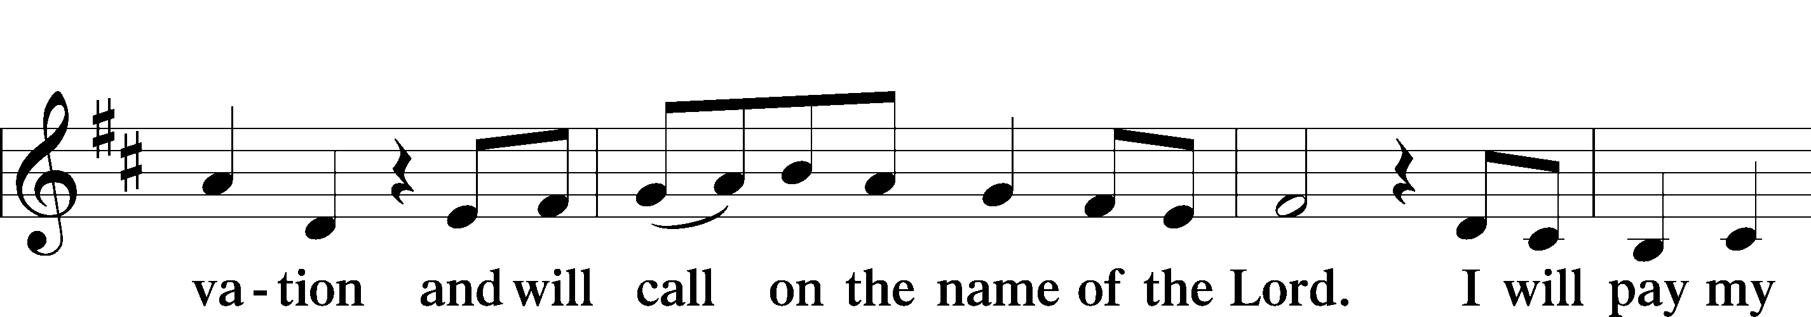

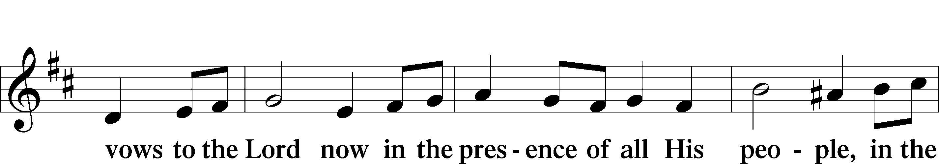

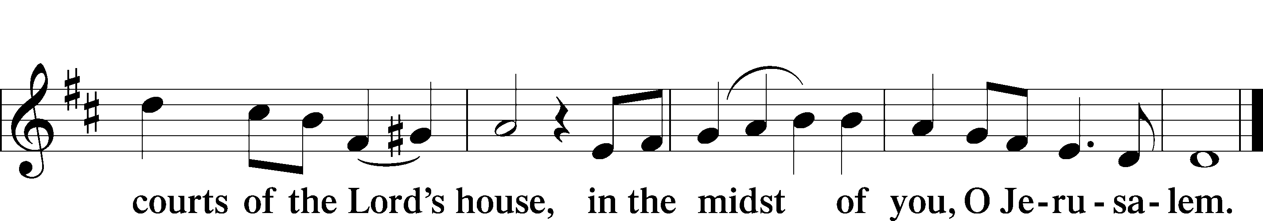

Prayer of the Church

Lord’s Prayer

C **Our Father who art in heaven, hallowed be Thy name, Thy kingdom come, Thy will be done on earth as it is in heaven; give us this day our daily bread; and forgive us our trespasses as we forgive those who trespass against us; and lead us not into temptation, but deliver us from evil. For Thine is the kingdom and the power and the glory forever and ever. Amen.**

Benediction LSB 183

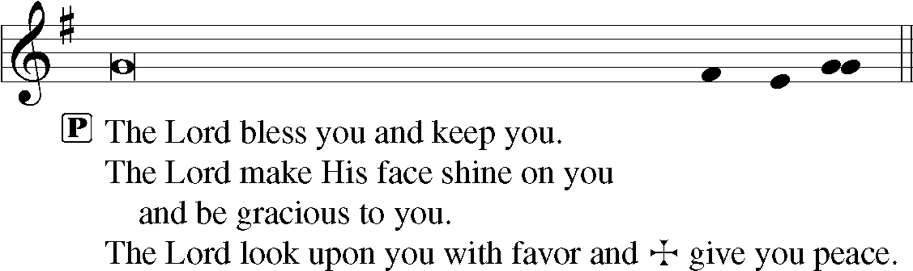

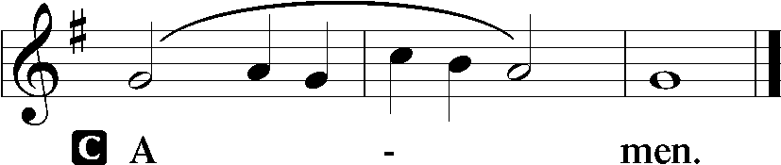

537 Beautiful Savior

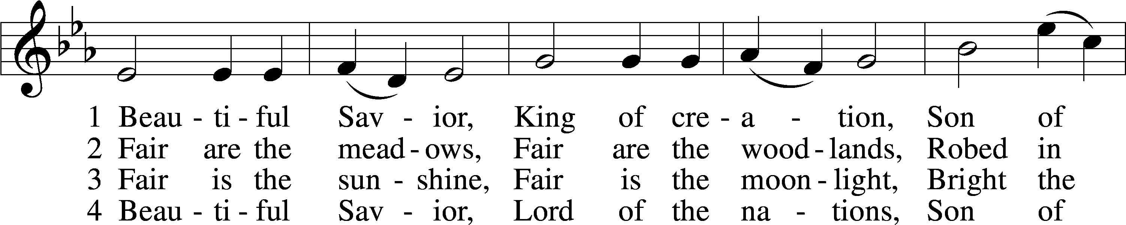

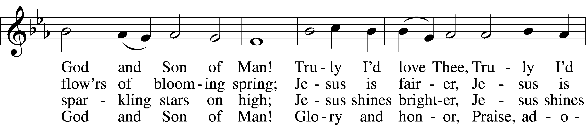

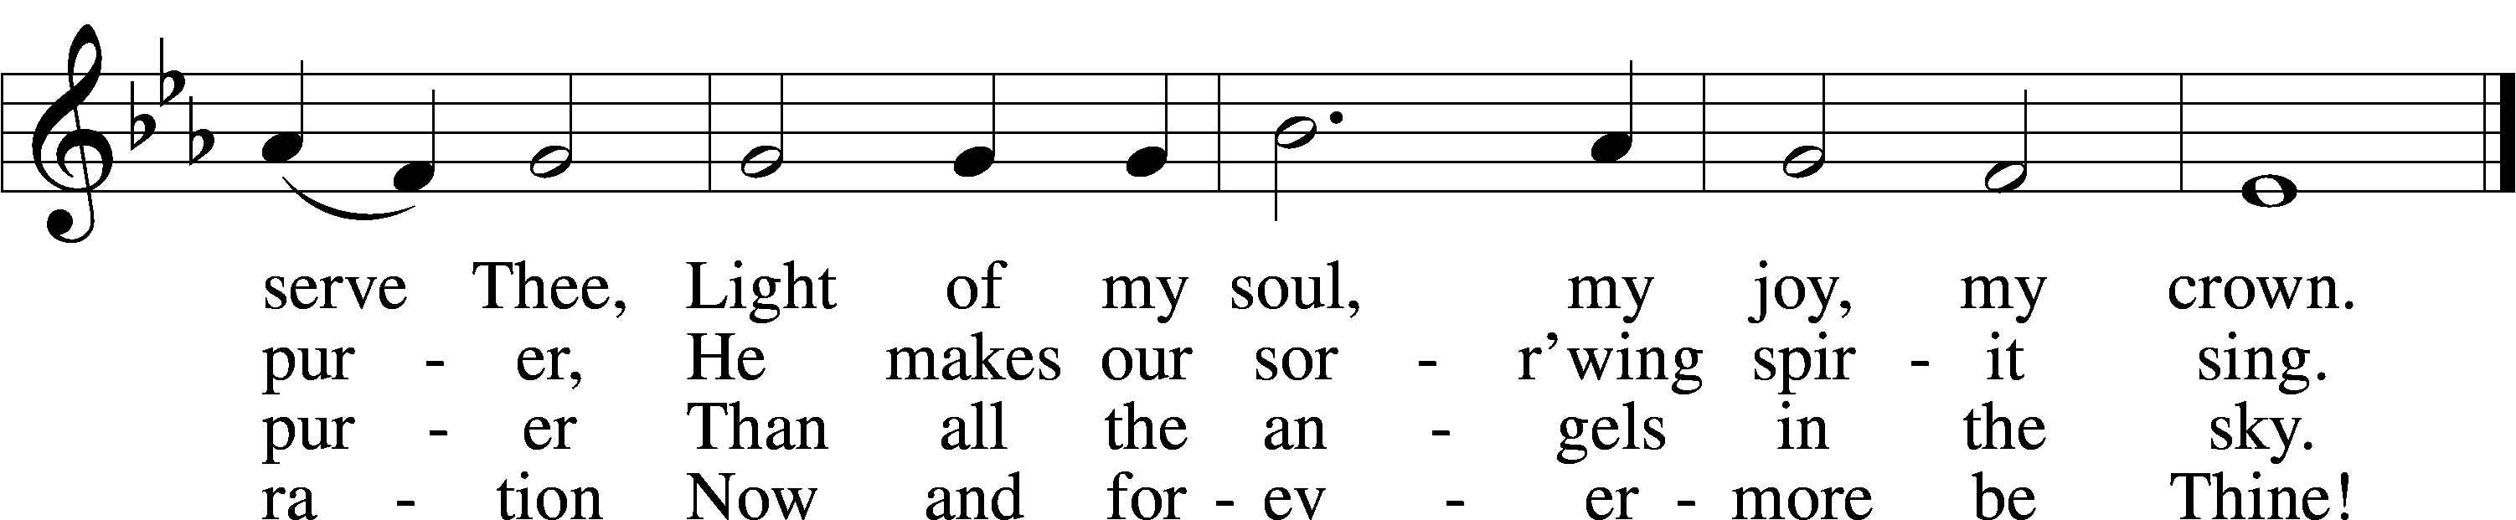

Text: Münsterisch Gesangbuch, 1677, Münster; tr. Joseph A. Seiss, 1823–1904  
Tune: Silesian, 19th cent.  
Text and tune: Public domain

Acknowledgments

Divine Service, Setting Two from Lutheran Service Book

Unless otherwise indicated, Scripture quotations are from the ESV® Bible (The Holy Bible, English Standard Version®), copyright © 2001 by Crossway, a publishing ministry of Good News Publishers. Used by permission. All rights reserved.

Created by Lutheran Service Builder © 2024 Concordia Publishing House.